WILDLIFE ACTS 1976 TO 2018 - SECTION 22(9)(d)

APPLICATION FOR LICENCE TO EXAMINE, INSPECT OR TAKE THE NESTS OR EGGS OF PROTECTED WILD BIRDS FOR EDUCATIONAL, SCIENTIFIC OR OTHER PURPOSES

ALL DETAILS TO BE FILLED IN FULL, IN BLOCK CAPITAL LETTERS
Name of applicant:
Address: (in full)
 |  |  | Eircode:
Email Address:
Telephone No: (Landline / Mobile)
 |  |  | Please fill in where necessary overleaf:
**N.B. Where necessary attach any additional relevant information.**
DECLARATION

I declare that all particulars are correct to the best of my knowledge and belief, and I apply for a licence in accordance with these particulars.

I understand that any false declaration may lead to having my licence revoked.
Signature: …………………….……………………… |  |  |  |  | Date: ………………………….……..
Please return the completed  application form to:  Wildlife Licensing Unit (R. 2.03)  National Parks & Wildlife Service  90 King Street North  Smithfield  Dublin 7  D07 N7CV  Email: wildlifelicence@housing.gov.ie |  |  |  | 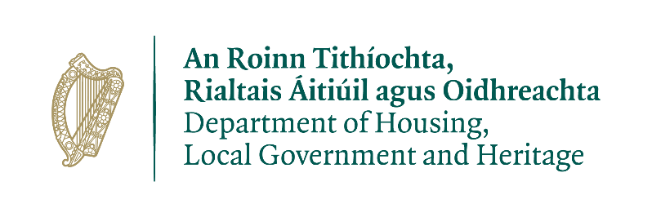

ALL DETAILS TO BE FILLED IN FULL, IN BLOCK CAPITAL LETTERS
- Purpose of licence:

- Species Name: (Common & Scientific)

- Area(s) in which applicant will operate: (e.g. county & townland) (map(s) may be requested)

- State qualifications/experience in this field of activity:

- State any other supporting licence/permit(s): (include photocopy with application)

- Organisation to which applicant is affiliated:

- Period for which licence is required: (include start/end date:)

- Number of previous licence (if any) and date of expiry:

Note: That insufficient information will lead to a delay in issuing your licence

License application under the Wildlife Act 1976 to 2018
PRIVACY STATEMENT

Please note that under Data Protection legislation Department staff may only discuss licence applications with the applicant, and not a third party. See Privacy Statement at www.npws.ie/licences

