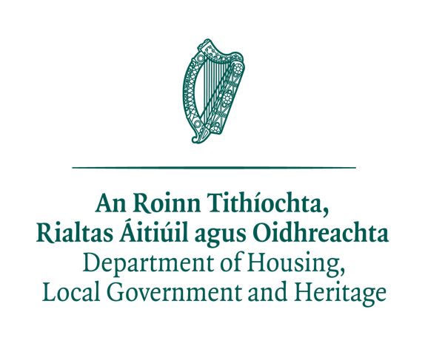

WILDLIFE ACTS 1976 TO 2018 – SECTION 41
APPLICATION FOR A FALCONRY LICENCE
FOR USE ONLY BY OUT OF STATE APPLICANTS (INCLUDING NORTHERN IRELAND)
PLEASE COMPLETE IN BLOCK LETTERS

NAME: _____________________________________________________________
AGE (IF UNDER 18):___________________________________________________________
ADDRESS: _____________________________________________________________
_____________________________________________________________
_____________________________________________________________
_____________________________________________________________
_____________________________________________________________
POST CODE: ______________________
E-MAIL ADDRESS:___________________________________________________________
TELEPHONE NUMBER/S:__________________ ______________________
ARE YOU A FIRST TIME APPLICANT: YES __ NO__
CURRENT LICENCE NUMBER (IF APPLICABLE)______________________
LICENCE FEE
LICENCE TO ENGAGE IN FALCONRY IN THE REPUBLIC OF IRELAND
FEE €12.70 PER APPLICANT ANNUALLY

ALL FEES SHOULD PAID IN EUROS ONLY BY: CHEQUE OR POSTAL ORDER TO: DEPARTMENT OF HOUSING, LOCAL GOVERNMENT AND HERITAGE. For EFT
PAYMENTS (Electronic Funds Transfer) contact Wildlife Licensing Unit directly for details
CASH PAYMENTS CANNOT BE ACCEPTED AND WILL BE RETURNED

BIRDS THAT WILL BE FLOWN IN THE REPUBLIC OF IRELAND
SPECIES | AGE | SEX | RING NUMBER | MICROCHIP NUMBER

PLEASE INDICATE:
DATE(S) YOU WILL VISIT THE REPUBLIC OF IRELAND | LOCATION(S) YOU WILL BE FLYING YOUR BIRDS

PLEASE ALSO ENCLOSE:
PROOF OF OWNERSHIP AND/ OR CITES /ARTICLE 10 CERTIFICATES, WHICH ARE REQUIRED FOR ALL BIRDS THAT ARE TO BE FLOWN IN THE REPUBLIC OF IRELAND
I HEREBY DECLARE THAT THE FOREGOING PARTICULARS ARE, TO THE BEST OF MY KNOWLEDGE AND BELIEF, TRUE AND CORRECT IN EVERY PARTICULAR.
SIGNATURE: _________________________________________ DATE: ________________________________
IN ORDER TO AVOID UNNECESSARY DELAY IN PROCESSING YOUR APPLICATION, PLEASE ENSURE THAT YOU HAVE FULLY COMPLETED THIS FORM AND MADE THE REQUIRED PAYMENT.
COMPLETED FORMS SHOULD BE SENT TO:
DEPARTMENT OF HOUSING, LOCAL GOVERNMENT AND HERITAGE
WILDLIFE LICENSING UNIT
NATIONAL PARKS AND WILDLIFE SERVICE
90 KING STREET NORTH
DUBLIN 7
D07 N7CV

TELEPHONE: + 353 1 888 3242 EMAIL: wildlifelicence@chg.gov.ie

