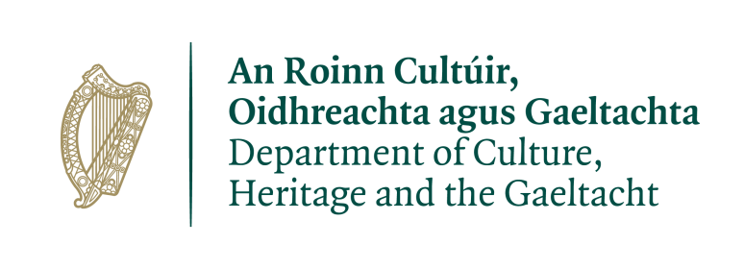

DEER HUNTING SEASON 2018-2019

Dear Sir/Madam,
Enclosed is an application form for a licence to hunt deer for the 2018-2019 hunting season. If you are applying for a licence you should return this form fully completed to the address below. Guidance in completing the form is also enclosed, together with copies of landowner permission forms.
It should be noted that licences will be issued from early August 2018, but not before, as the licensing season does not start until 1st September. Applications will be processed in order of the date of receipt and incomplete applications will result in your application being returned.
If you are not the landowner, your application must be accompanied by written permission(s) for the 2018-19 season. The enclosed form should be used and must be signed and dated by the landowner or person entitled to the sporting rights.
All non-resident applicants must submit a copy of their European Firearms Pass in addition to their application form and land permission form(s).
If you previously held a deer hunting licence you must fully complete Part 4 (Returns) of the form for deer shot for the last season you held a licence.
To ensure you receive your licence in time for the 2018-2019 hunting season, please return your completed;
- Application form and
- Land owner permission form(s) and
- Part 4 (Returns) – if you held a licence previously
before the end of June 2018

Department of Culture, Heritage and the Gaeltacht
Wildlife Licensing Unit
National Parks and Wildlife Service
90 North King St., Smithfield
Dublin 7 D07 N7CV

Email: wildlifelicence@chg.gov.ie

April 2018.
P.T.O.

To get your licence on Time:

APPLY
BEFORE
1st JULY

This Department is committed to issuing your licence as quickly as possible.

We will contact you if we have any query with any form you submit to us.

