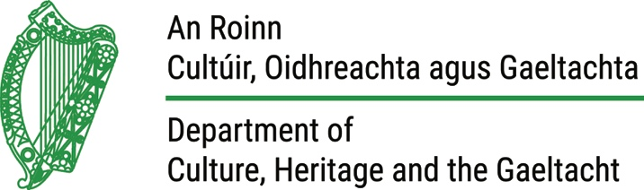

CIRCULAR: 1 / 2018

December 2017

BIRDS OF PREY LICENCE APPLICATIONS AND INSPECTIONS 2018

Dear Sir / Madam,

I am directed by the Minister for Culture, Heritage and the Gaeltacht to refer to the above matter.

All current Bird of Prey possession and Falconry licences issued under the Wildlife Act 1976 (Birds of Prey) Regulations 1984 (S.I. No.8/1984) will expire on Wednesday 31 January 2018. It should be noted that it is an offence under the above Regulations to be in possession of a bird of prey or to engage in falconry without a licence.

A licence application form to facilitate the renewal of your licence(s) is enclosed and this form should be completed and returned to, Wildlife Licensing Unit, National Parks and Wildlife Service, Department of Culture, Heritage and the Gaeltacht, 7 Ely Place, Dublin 2, D02 TD98.

Completed application forms and the appropriate fee should accompany your application, which is €12.70 annually for Possession and Falconry licences. This office will issue an acknowledgement to all applicants confirming receipt of their application.

Licence to Take a Bird of Prey from the Wild
If you wish to apply for a licence to take a bird of prey from the wild during the coming breeding season, your application must reach this office not later than 5pm Wednesday, 31th January 2018. Please note that you are required to indicate that you have land owner permission for each wild-take site applied for. Appendix 2 sets out the conditions regarding participation in the Peregrine Falcon draw 2018.

Please note that late applications for wild-take licences will not be considered.

There is no fee for the licence to take a bird of prey from the wild. Therefore, if you have no birds in your possession at the moment and are applying (only) to take a bird of prey from the wild, you should not send any fee with your application. However, if you are granted a wild-take licence and are successful in taking a bird of prey from the wild, you must apply for a possession licence to keep the bird and the fee will be required at that point. Again, an acknowledgement will be issued to all applicants confirming receipt of their application.

Inspection of Premises
Part of the licensing process involves an inspection of the accommodation that you provide for your birds of prey and an examination of those on your licence application form. Current licence holders are required to assist National Parks and Wildlife Service staff in this inspection process. It is recommended that you should contact your local Conservation Ranger and arrange an inspection as a matter of priority.

It should also be noted that on the day of inspection, licence holders will be required to make themselves or their representatives available at the premises. They should present their birds of prey in such a manner as to facilitate the easy identification of all birds on the licence application form and comply with the requests of National Parks and Wildlife Service staff.

To Possess an Injured Wild Bird
An application under Sections 22(9)(g) and 22(9)(h) of the Wildlife Acts 1976 to 2012 should be applied for when an injured wild bird has come into your possession. This should be applied for immediately and your local Conservation Ranger should be contacted.

It is considered that generally all injured wild birds should be eventually rehabilitated and released back into the wild. In the event that a bird cannot be released back into the wild, you should apply to have the bird micro-chipped by a registered veterinary surgeon and added to your possession licence.

PLEASE NOTE: If the wild bird is CITES listed, you must also apply for a CITES (Article 10) Certificate. A wild taken specimen may not be used for commercial purposes. However, subsequent generations may be used for commercial purposes, subject to CITES certification. See appendix 3 for more details.

Adding and Removing Birds of Prey from Possession Licences
When acquiring a bird of prey, it is important to remember that you must have the bird added to your possession licence before you take possession of it. To ensure this, you should complete Appendix 1 of the application form and forward it by e-mail to wildlifelicence@chg.gov.ie or by post to the Wildlife Licensing Unit with all the relevant details (species, sex, identification number and details of proposed provider). Your request will be referred on to the relevant regional NPWS staff for consideration. Applicants should ensure that adequate time is allowed for this process to be completed.

Upon approval, your possession licence will be amended and an updated licence will be issued to you. It is only at this stage that you can take possession of the bird. It is also recommended that you indicate to the prospective provider that you hold a current possession licence with the bird listed on it.

The Appendix 1 form should also be completed and returned when requesting to remove a bird of prey from a current possession licence. The Appendix 1 form is also available on our website http://www.npws.ie/licences/possession/.

Future Communication by the Department
Future circulars and general correspondence will be issued via email to those who have supplied email addresses. Therefore please ensure that your email address is stated clearly and correctly on your application form. A hardcopy of your licence will continue to be issued by post.

If you have any queries, please contact the Wildlife Licensing Unit at (01) 888 3279.

Yours sincerely

Lynn Mc Donnell

Wildlife Licensing Unit
National Parks and Wildlife Service
7 Ely Place
Dublin 2
D02 TW98

