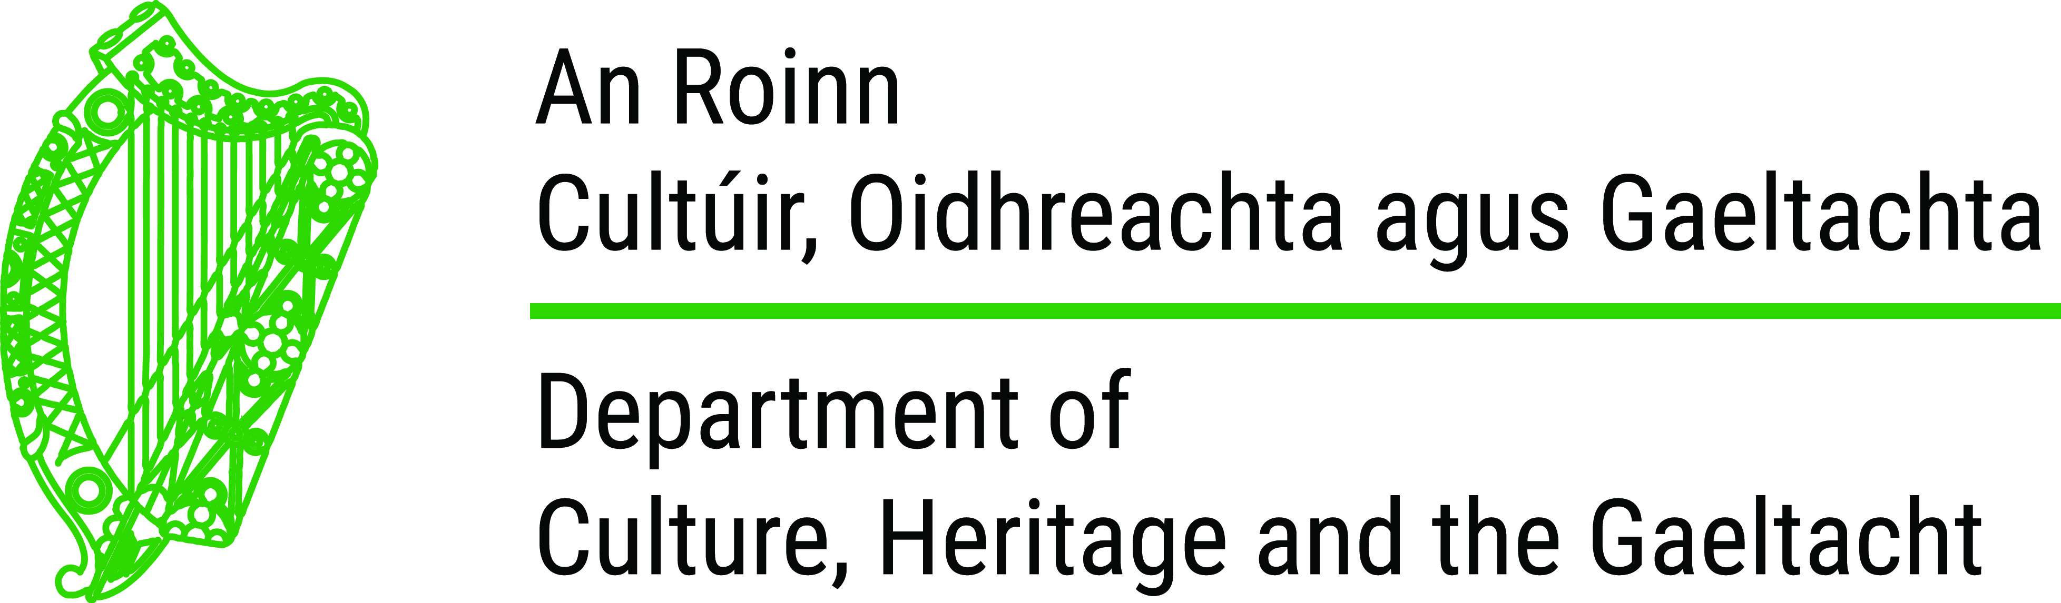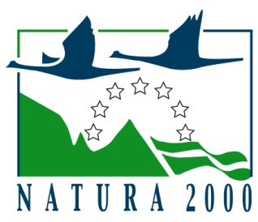

APPLICATION FORM A

TO BE COMPLETED BY APPLICANT

Peatlands Community Engagement Scheme

Pilot 2018

PLEASE NOTE THE FOLLOWING BEFORE COMPLETING THIS FORM

- Form A must be fully completed – incomplete applications will not be accepted

- Please type in the relevant information, if possible

- If handwritten, please use BLOCK CAPITALS or ensure script is legible

- All date entries should be entered in the format DD/MM/YYYY

- A Method Statement must be submitted by applicants with Form A where it is proposed for works to be undertaken. Further details are set out above as to what should be included in the Method Statement.

- Where Ministerial consent has been applied for but no decision has been made at the time of application to the scheme, state this in Section 3 including the case reference number issued.

- Details of how the cost of the works, other than the amount of funding sought, is to be met must be stated in Section 5. The applicant must indicate the matching amount total and the source of matching funds.

- Applicants must submit by 4pm on 16 July 2018, 1 copy of the completed and signed application form along with a Method Statement for works where relevant and any other supplementary materials, where relevant, preferably by post to:

Peatlands Management Unit,
Department of Culture, Heritage and the Gaeltacht,
Newtown Road,
Wexford.
Y35 AP90

- Electronic applications will be accepted by the deadline of 4pm on 16 July 2018 to peatlandsmanagement@chg.gov.ie but hard copies of the application must be submitted within one week of this date.

1. Applicant (s) Details
Name:

Address:

Telephone/Mobile Number: |  | Email:
Charity Number: (if applicable)

Applicant Group Status:
Tax Reference Number together with Tax Compliance Access No.: |  | Date:
Please indicate if the consent of the owner/affected owners has been obtained to apply for this scheme (Note: written consent must be submitted with the application)

2. Project/Event/Activity/Works Details
Type of Project/ Event/Activity/Works:

Address of where Project/Event/Activity/Works will take place:

3. Statutory Notifications
 | Yes or No | If yes: enter date applied/received
Does the proposed project/event/activity/works require or has it been granted planning permission? |  | Date applied:
 |  | Planning Status:
 |  | Planning Ref. No:
Does the proposed project/event/activity/works require Ministerial Consent or permission from other consent authorities? |  | Date applied:
Date received:

Reference No:

4. Project/Event/Activity/Works Summary
 | Summary
In no more than 300 words, summarise the proposed project/event/activity/works having regard to:

(a) The significance of the project/event/activity/works

(b) The effectiveness of the project/event/activity/works

(c) The capacity to deliver the project/ event/ activity/works

(d) How the project/event/activity/works will benefit the community and promote raised bog conservation awareness

(e) How the project meets national conservation objectives for raised bogs

(see www.npws.ie for the following publications ‘National Peatlands Strategy’, ‘the National Raised Bog Special Areas of Conservation Management Plan 2017-2022’ and the ‘Review of Raised Bog Natural Heritage Area Network’)

Start and finish dates of proposed project/event/activity/works? | Start: | Finish:

5. Expenditure in relation to proposed Project/Event/Activity/Works
Estimated Total Costs of Works: | €  (excluding VAT) | €  (including VAT)
Estimated Professional Fees: | €  (excluding VAT) | €  (including VAT)
Total funding sought: | €
Amount of matching funds: | €
Source of matching funds

6. Other Grants/Funding & Reliefs
Is VAT recoverable?

Have you applied for other EU/Exchequer funding/Tax Reliefs?

Have other EU/Exchequer funding /Tax Reliefs been received/refused?

7. Contractors/Tradespersons/ Personnel employed on the project/works/event/activity

Contractor(s)/Tradesperson(s)/(Personnel) 1
Name: |  | Position:
Address:

Telephone/Mobile Number: |  | Email:
Tax Reference Number: |  | Date:
Satisfactory level of subcontractor tax compliance demonstrated: (if applicable)* | Yes: | No:

Contractor(s)/Tradesperson(s)/(Personnel) 2
Name: |  | Position:
Address:

Telephone/Mobile Number: |  | Email:
Tax Reference Number: |  | Date:
Satisfactory level of subcontractor tax compliance demonstrated: (if applicable)* | Yes: | No:

Contractor(s)/Tradesperson(s)/(Personnel) 3
Name: |  | Position:
Address:

Telephone/Mobile Number: |  | Email:
Tax Reference Number: |  | Date:
Satisfactory level of subcontractor tax compliance demonstrated: (if applicable)* | Yes: | No:

If necessary, copy this page to include additional contractors/tradespersons/personnel.

PLEASE ATTACH DETAILED WRITTEN QUOTES FOR THE PROJECT/EVENT/ACTIVITY/WORKS ALONG WITH A METHOD STATEMENT WHERE NECESSARY.

8. Declaration by Applicant/Group

I, the applicant, certify that:

- I understand and fulfil all the terms and conditions of the Peatlands Management Community Engagement Scheme.

- The information provided in the application form and supporting documents is correct and I will notify the Department if there is any change in that information.

- I am providing at least €________ from my/<insert group/body’s name> own resources towards the Project/Event/Activity/Works.

- I am/Group are /<insert groups/body’s name> are tax compliant.

- I understand that the Department of Culture, Heritage and the Gaeltacht may retain and process personal information contained within this form and any associated documents provided and I understand that it will be used only for the purposes of the administration of this scheme and to establish eligibility for funding under this scheme.

Applicant’s Signature: _________________________ Date: _________________

Block Capitals: _________________________

12. Checklist for Applicants (Insert Yes or No accordingly)

The following must be included in all applications | Applicant  Yes/No | Comment
Form A - Fully completed
Method statement attached (if applicable)
Site location map with location of works clearly marked in red (if applicable)
Evidence of Tax Compliance/Charity Status submitted (if applicable)

Written consent of owner/affected owners for proposed works/project/event/activity (if applicable)
Provide photographs which illustrate the project before works commence, which may be used later for a ‘before and after’ comparison for reporting purposes where applicable
Detailed written quotes attached
Legal status of organisation/group/body attached

DCHG OFFICAL USE ONLY

