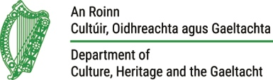 | Curlew Conservation Programme  Curlew Action Team Application Form | 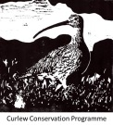
All fields must be completed
Please complete using MS Word and email to Agri.Ecology@chg.gov.ie (note dot between ‘Agri’ and ‘Ecology’) or if filling in by hand, use BLOCK CAPITALS and post to Agri-Ecology Unit, NPWS, 7. Ely Place Dublin 2. You are free to apply for more than one position. Applications must be received before 1700 on Wednesday 28 February 2018.

Section A
My personal details are
Name
Address
Phone Number
Email Address

Section B (mark as appropriate)
I would like to apply for the position(s) of in the following geographical area(s)
Curlew Advisory Officer |  | Stack’s Mountains
Curlew Champion |  | Lough Ree
Nest Protection Officer |  | North Co. Roscommon
Curlew Action Team Assistant |  | North Co. Leitrim
------------------------------------------------------ |  | North Co. Monaghan
------------------------------------------------------ |  | Co. Donegal

Section C
My daily rate (inclusive of travel costs) for the position(s) is/are
Position | Daily Rate (ex VAT)* | Daily Rate  (incl. VAT if registered)*
* The ex VAT rate will be used to compare between applications for the positions applied for.
Section D
My experience relevant to the position(s) includes

Some of my other work or personal experience includes (not necessarily relating to work)
Experience | Year(s) | Time (in months)

Section E
My qualification for the position(s) includes

Section F
The following two people can supply character references for me
Referee 1 |  | Referee 2
Name |  | Name
Position |  | Position
Relationship to me |  | Relationship to me
Postal Address |  | Postal Address
Phone Number |  | Phone Number
Email Address |  | Email Address

Section G
I feel I am well suited to the position(s) and can contribute in a proactive way because
In making this application, I confirm that I am over 18, that I have access to a vehicle for the purpose of the duties of the role and that I am available for the period required (see role descriptions). If I am applying for Nest Protection Officer, I confirm that I do not have firearms or Wildlife Act offences to my name.

