IRELAND’S INVASIVE ALIEN SPECIES RECREATIONAL BOATING AND WATERCRAFT PATHWAY ACTION PLAN
2022 – 2027
Actions to reduce the risk of introduction and spread of invasive alien species transported by recreational boating and watercraft activities
This document was prepared by the National Biodiversity Data Centre on behalf of the National Parks and Wildlife Service. Key to its drafting is the participation and contribution by the Recreational Boating Invasive Alien Species Pathway Action Plan Working Group.
This Pathway Action Plan builds upon the guidance issued in the 2016 European Code of Conduct on Recreational Boating and Invasive Alien Species, the Inland Fisheries Ireland biosecurity guidance and, the United Kingdom Check Clean Dry biosecurity campaign amongst others.

Contents
Introduction 2
Scope 2
Description of the target pathway 3
Policy and legal context 7
Aim and objectives 8
Identification of key stakeholders 9
Key Actions and Outcomes 9
Horizontal measures to support implementation of the Key Actions 12
Pathway Action Plan management 13
Time schedule 13
Summary note 14
Appendix I – Working Group Members 15
Appendix II – Recreational boating biosecurity guidance 16
Decision tree to help identify the biosecurity actions required 17
Biosecurity measures per stakeholder level 18
EU Code of Conduct on Recreational Boating and Invasive Alien Species – biosecurity guidance 19
The EU Code of Conduct on Recreational Fishing and Invasive Alien Species 21
Appendix III - Priority concern DRAFT list of invasive alien species 25
Reporting sightings of invasive alien species 27
Appendix IV – Check Clean Dry biosecurity campaign awareness resources 28

Introduction
An Invasive Alien Species is a species occurring in an area outside of its historically known natural range as a result of intentional or accidental dispersal by human activities and whose introduction or spread, has been found to threaten or adversely impact upon biodiversity and related ecosystem services.
The introduction of invasive alien species into aquatic environments can significantly impact on the wildlife, habitat structure and functioning of the waterbody. This affects human dependence and interactions with the waterbody including the loss or alteration of fisheries, clogging of waterbodies and waterways, affecting water quality and supply, and impacts on recreational boating, water sport and recreational activities including angling. Once invasive alien species become established in waterbodies it can be very difficult, if not impossible, to control or eradicate them. The presence of these invasive alien species can also affect the ability of agencies or managers to maintain the ecological quality and halt degradation of the environment.
As invasive alien species can be unintentionally transported with recreational boating and watercraft activities, action is needed to reduce the risk of introducing and spreading invasive alien species into and between waterbodies in Ireland by this pathway. Aquatic invasive alien species can impact on recreational boating by fouling submerged structures and boats, blocking water intakes, increased maintenance costs, impeding and affecting navigations and impacting on recreational access to waterbodies. Therefore, action can also directly benefit the sector.
Developing action plans to tackle the priority pathways of unintentional introduction and spread of invasive alien species of Union concern in Ireland is a requirement under the EU Invasive Alien Species Regulation. This Pathway Action Plan targeting the unintentional transport of alien species with recreational boating and watercraft is one of a series of plans intended to reduce the risk of introduction and spread of alien species in Ireland.

This Recreational Boating and Watercraft Pathway Action Plan outlines the general policy approach to tackling this pathway and what actions government and those involved with boating in Ireland can undertake.

Scope
The scope of this Pathway Action Plan is on activities related to recreational boating and watercraft in the freshwater, brackish and marine environments. Recreational boating refers to boats that are designed or adapted for sport or leisure. They can be beach, shoreline, riverbank, crane or slipway launched. This includes yachts, wind surfers, dinghies, inflatable boats (including RIBs), Jet-skis, canoes, kayaks, rowing boats, cruisers, barges and other personal watercraft. It also refers to any equipment or clothing that comes in contact with the water such as trailers and wetsuits etc. It comprises the use of boats privately owned and operated by the owner, hired or used to provide a service such as training and race participation.
While the geographic scope of the plan is the Republic of Ireland, given the significant connectivity, close proximity and ease of access between cross border waterways, aspects with Northern Ireland are referred to as well as linkages with Great Britain and continental Europe.

This Recreational Boating and Watercraft Pathway Action Plan is aimed at all those engaged in recreational boating and watercraft activities whether it be individual boaters, clubs, training centres, those commercially engaged with recreational boating such as outdoor pursuit centres, charters and marinas, non-governmental organizations, water management fishery, waterway, navigational and port authorities and agencies that regulate recreational boating and other water sport activities.

Description of the target pathway
What is this pathway? Plants, animals or pathogens can be unintentionally transported when watercraft and associated boating or watercraft equipment and clothing come into contact with the water. When moving from a waterbody, if the watercraft and equipment has not been properly checked, cleaned, dried and/or disinfected before being used in another waterbody, non-native species may survive transport on the equipment and be introduced to a new waterbody where it could become invasive. It has been shown that some invasive alien species and pathogens do not need to be submerged in water during transport but can survive in damp conditions and without hosts. For instance, African curly waterweed (Lagarosiphon major) plant material can remain viable for at least seven days; killer shrimp (Dikerogammarus villosus) for 15 days; crayfish plague spores (Aphanomyces astaci) for 3 weeks and Gyrodactylus (aka Salmon fluke) (Gyrodactylus salaris) for 2-5 days. It is important to note that some invasive species may not be visible to the naked eye. For example spores or even the juvenile stages of zebra and quagga mussel can be less than 1mm in size - cleaning should take place even if nothing is visible to the naked eye.
One of the main vectors of spread can be boat hulls or propellers and within bilge water or engine cooling water systems. Invasive alien species can also attach to other equipment or clothing that comes in contact with the water such as trailers, anchors, buoys, outboard engine, tyres, paddles, wet suits, footwear etc.
Since the 1980’s the rate of introduction of aquatic invasive species has accelerated with introduction of invasive alien species such as Zebra mussel (Dreissena polymorpha), Asian clam (Corbicula fluminea), Chub (Squalius cephalus), Didemnum vexillum, Wireweed (Sargassum muticum) and pathogens such as the crayfish plague (Aphanomyces astaci) being introduced into Ireland. The number of locations that aquatic invasive alien species are being recorded in Ireland is also increasing. With more invasive species poised to be introduced to Ireland from Great Britain and continental Europe, good awareness and implementation of biosecurity measures by all relevant stakeholders is required.
In general, the term biosecurity relates to measures taken to prevent the introduction and spread of living organisms.
In the absence of implementing appropriate biosecurity measures, there is an increased potential for the inadvertent spread of viable invasive alien species with recreational boating and watercraft from infested to un-infested waters.
What is the scale of the activity related to this pathway in Ireland?
Ireland has an abundance of freshwaters with over 12,200 lakes, an extensive river network estimated to be 74,000km in length, artificial or heavily modified water bodies including reservoirs and canals, 7,700km of coastline and access to marine waters that span approximately 900,000km.
While there are no overall figures for the expenditure or numbers of domestic and overseas visitors engaging in recreational boating and watercraft activities, the below figures indicate the volume of engagement and value of the sector to the economy.
Marine water-based activities
- In 2019, marine domestic tourism expenditure was estimated at €381 million with an estimated €172 million being spent on water-based activities.
- In 2018, marine tourism by overseas visitors makes up an estimated 12% (at €650 million) of total overseas tourism expenditure with €198 million being spent on marine water specific activities.⁶
- The Government’s 2018 National Marine Planning Framework Baseline Report notes that 196,000 overseas tourists engaged in water-based activities in 2016 (excluding swimming, sailing and angling).
- Fáilte Ireland’s estimate for overseas tourists engaging in sailing (based on 3-year averages) is approximately 40,000 per annum.⁸
- Out of a total of 4.9 million domestic holiday trips in 2017, about 1 in 5 (21%) domestic holidaymakers engaged in marine water sports (excluding swimming), and 3% engaged in angling.⁸
Inland water activities
- A survey of waterway users in 2017 found that half (49%) are domestic visitors, 1 in 3 (34%) are local and almost 1 in 5 are from overseas. The research also indicated that overseas visitors spend most time on the waterway at an average of 4 days.
- While walking is the most popular activity on the waterways with 32% noting it as their main activity, the next most popular were dominated by in-water activities:
  - Boating (private cruiser/barge) 15%
  - Angling 8%
  - Boating (boat trip) 8%.⁹
The Irish Marine Federation’s (IMF) published submission and response to the National Marine Planning Framework Baseline Report note the ‘traditional and important cruising routes into Ireland from Wales, South West England and Scotland’. For inland waterways, anecdotally [Waterways Ireland pers. Comm., 19th November 2020], the key foreign boat origins are the UK (Lake Cruisers and UK Canal Barges) and Holland (Canal Barges and Dutch Canal Barges - many of which come into the Shannon system through Limerick due to size).
Recreational boating and watercraft sporting events also attract competitors moving between water catchments in Ireland and from abroad. For instance, sailing events, such as the Dun Laoghaire Regatta, attract as many as 2,500 competitors, making it one of the biggest participant sporting events after the Dublin marathon.’. ¹⁰ The Liffey Descent canoe marathon attracts hundreds of domestic and international participants every year. Several competition festivals also draw participants from around Ireland and overseas such as the Rosslare Small Boats Festival, the Cork Small Boats Festival, the Absolute Fishing Irish Bass Festival and the Dingle Daiwa Pairs Sea Angling Festival. The Inland Waterways Association of Ireland (IWAI) organises several boat rallies and cruise in company events every year. While many remain within the same catchment, some do involve moving boats between catchments [Inland Waterways Association of Ireland, pers. comm., 22nd October 2020]. In 2013, of the 124 participants in the Dingle Daiwa Pairs Sea Angling Festival, 93 were from Great Britain, while 18 travelled from other parts of Ireland and stayed in the region and 13 were locals.

These surveys highlight the domestic and overseas participation in recreational boating and watercraft activities in Ireland and of the significant socio-economic value associated with those activities. Correspondingly, there are policy objectives to increase such participation into the future. One of the sports and recreation objectives in the National Marine Planning Framework Consultation draft, is ‘Increased participation in a range of water-based sports and recreation activities for the benefit of public health and wellbeing, as well as developing our tourism offering.’. Likewise, the Inland Fisheries Ireland 2015 National Strategy for Angling Development aims to increase angling activity both domestically and from overseas visitors. The Tourism Masterplan for the Shannon 2020-2030. sets an integrated framework for sustainable tourism development along the Shannon and Shannon Erne Waterway repositioning the region as a key tourism destination within Ireland’s Hidden Heartlands.

However, along with measures to promote engagement in this sector, measures to reduce to the risk of negative socio-economic impacts on this sector by introduction of invasive alien species are also required. The National Marine Planning Framework Consultation draft report recognises the invasive alien species associated risk with recreational activities noting ‘in certain instances human leisure activities can have potentially adverse impacts for the marine environment through, for example: introduction of non-native species into an area on recreational boats and crafts.’ Biosecurity measures outlined in the Tourism Masterplan for the Shannon 2020-2030. seek to address this issue. This plan sets out an integrated framework for sustainable tourism development along the Shannon and Shannon Erne Waterway repositioning the region as a key tourism destination within Ireland’s Hidden Heartlands. Formal biosecurity standards for the inland waterways are set out in the plan, see Box 1. This provides an example approach for setting actions to counteract the potential risk of introduction and spread of invasive species as part of sustainable tourism.

Box 1. Tourism Masterplan for the Shannon 2020-2030
Section 6.6.4 of the Plan ‘proposes a number of formal biosecurity standards for the inland waterways to be implemented which aim to prevent the inadvertent disruption of the Shannon’s natural ecosystems. These measures are required across the masterplan area.
Draft standards were developed as part of the masterplan, which focus on communications, freshwater security measures for small boats and standards for leisure and industrial craft entering the system.
The introduction of biosecurity facilities at designated entry points should be considered for all users along the Shannon to reduce the risk of further introduction or spread of invasive species. These should include:
- anti-fouling stations for routine boat cleansing procedures.
- cleansing / power washing stations for incoming/outgoing craft.
- well placed and well serviced pumping stations to prevent unlicensed bilge discharge; and
- spot inspections by licensed navigation staff.’

Policy and legal context
The prevention of introduction of non-native and potentially invasive alien species into Europe and Ireland has long been a feature of legislation and policy. The most relevant European policy instruments include the Bern Convention, the COUNCIL REGULATION (EC) No 708/2007 of 11 June 2007 concerning use of alien and locally absent species in aquaculture; the Water Framework Directive; the Marine Strategy Framework Directive and the 2014 EU IAS Regulation¹. Relevant domestic legislative instruments include:
- Wildlife Act 1976 – updated to 21 November 2021
- Wildlife (Amendment) Act, 2000
- S.I. No. 477/2011 - European Communities (Birds and Natural Habitats) Regulations 2011
- European Communities (Marine Strategy Framework) Regulations S.I. No. 249 of 2011

National policy includes actions under:
- Ireland’s third National Biodiversity Action Plan 2017-2021 whereby Target 4.4 states that ‘Harmful invasive alien species are controlled and there is reduced risk of introduction and/or spread of new species.’ This is supported by 7 actions in the plan.

- The Biodiversity Climate Change Sectoral Adaptation Plan whereby Action 1.6. is to ‘Establish and implement an all-island invasive species programme to monitor the spread of terrestrial, aquatic and marine invasive species in a changing climate and control invasive species where their spread is considered problematic’.

- The Marine Strategy Framework Directive (MSFD) (Directive 2008/56/EC) whereby Descriptor 2 stipulates that ‘Non-indigenous species introduced by human activities are at levels that do not adversely alter the ecosystems’. Ireland’s environmental target for non-indigenous species aligned to the primary criterion for this descriptor is ‘The number of non-indigenous species which are newly introduced via human activity into the wild, per assessment period is minimised and where possible reduced to zero.’

- The Water Framework Directive (WFD) (Directive 2000/60/EC) whereby in Ireland invasive alien species are considered a significant pressure. ‘The river basin public consultations on significant water management issues in 2015 identified Invasive Aquatic Species (IAS) as a significant issue for water management.’ It has been further identified that ‘invasive species are a significant pressure impacting 42 or 1.8% of the 1,460 At Risk water bodies. This total of 42 is made up of 7 river and 35 lake water bodies.’
Guidance aimed at recreational boating and watercraft activities to reduce the introduction and spread of invasive alien species have been advocated both nationally and internationally for many years. In 2012, the International Maritime Organisation (IMO) produced guidance to minimize the transfer of invasive alien species as biofouling. This guidance was intended for owners and/or operators of recreational craft less than 24 metres in length. Biosecurity guidance from this IMO document were included into the 2016 European Code of Conduct on Recreational Boating and Invasive Alien Species1. Since 2010, Inland Fisheries Ireland developed and led a biosecurity campaign with recreational water users including specific guidance for paddle sports equipment; boats and boating equipment; and scuba diving equipment. Irish Sailing have issued Guidelines for Event Participants and Support Crew whereby they recommend that competitors, team leaders, coaches, volunteers, race officers and all stakeholders endeavour to follow the guidelines at all events. Since 2018, the Department of Housing, Local Government and Heritage have been promoting the Check Clean Dry (CCD) public awareness campaign aimed at improving biosecurity amongst water users. The CCD campaign is adopted across Ireland, Northern Ireland, Great Britain, the Isle of Mann and Channel Island governments thus providing readily recognisable and consistent biosecurity messaging across those areas.

Aim and objectives
The aim of this Pathway Action Plan is to reduce the risk of invasive alien species being introduced to Ireland and to also reduce the risk of secondary spread from one waterbody to another within Ireland by recreational boating and watercraft activities.
Successful implementation of the Pathway Action Plan will support the implementation of regulation and policy and ultimately reduce the impacts of invasive alien species on waterbodies, the ecosystem services they deliver and the socio-economic benefits derived from them including recreational water sport activities.

The objectives to meet the aim of the Pathway Action Plan are:
- Increase the level of awareness of invasive alien species issues amongst recreational watercraft users.
- Increase level of awareness to demonstrate that by applying good biosecurity practice, recreational watercraft users will reduce the risk of introduction and spread of invasive alien species.
- Facilitate the uptake of good biosecurity practice by the recreational watercraft community.
- Communicate invasive alien species issues with the identified key stakeholders and fisheries owners, marina and boating facility operators, watercraft event organisers, tourism bodies, riparian land managers (private and public), anglers and the media.
- Encourage all stakeholders to report alert level invasive alien species to the National Biodiversity Data Centre.
- Set Key Action outcomes to enable review of implementation of the actions.
- Make recommendations for additional actions that would support the aim of this pathway action plan but are outside the scope of being achieved within it.

Identification of key stakeholders
Achieving the aim of this Recreational Boating and Watercraft Pathway Action Plan is dependent on close cooperation between the Department of Housing, Local Government and Heritage and other government agencies along with the key stakeholders to reduce the risk of further introduction and spread of invasive alien species to Ireland’s waters. The key stakeholders identified for this Recreational Boating and Watercraft Pathway Action Plan are:

- Angling Council of Ireland
- Boat hire companies
- Canoeing Ireland
- Department of Housing, Local Government and Heritage
- Diving Ireland
- Federation of Irish Salmon and Sea Trout Anglers
- Harbour masters
- Heritage Boat Association
- Inland Waterways Association of Ireland
- Inland Fisheries Ireland
- Irish Anglers Development Alliance
- Irish Boat Rental Association
- Irish Federation of Pike Angling Clubs
- Irish Marine Federation
- Irish Sailing
- Irish Water
- Local Authority Waters Programme
- Local Authorities
- Loughs Agency
- Marina operators
- National Anglers Representative Association
- National Biodiversity Data Centre
- National Coarse Fishing Federation of Ireland
- National Parks and Wildlife Service
- NAV-Watch
- Electricity Supply Board
- Salmon and Sea Trout Recreational Anglers of Ireland
- Sport Ireland
- The Irish Federation of Pike Angling Clubs
- The Irish Waterski and Wakeboard Federation
- Trout Anglers Federation of Ireland
- Waterways Ireland

Key Actions and Outcomes
Raising awareness
Action 1
Appropriately government funded survey of recreational boating and watercraft users’ levels of awareness on invasive alien species issues and biosecurity in 2023 to determine the baseline level of knowledge. Survey to be repeated in 2026 to provide a measure of the effectiveness of awareness raising activities.
Outcome: A measure of the effectiveness of actions taken to increase awareness on invasive alien species issues and aquatic biosecurity measures. It is expected there would be an increased level of awareness and adoption of biosecurity actions.
Action 2
The Recreational Boating IAS Pathway Action Plan Working Group will review and refine where necessary biosecurity campaign messaging and guidelines.
Outcome: Recreational Boating IAS Pathway Action Plan Working Group supported biosecurity campaign messaging and guidelines.

Action 3
The National Parks and Wildlife Service will implement a border aquatic biosecurity campaign targeting high risk routes of entry to Ireland from outside the island of Ireland. This will be primarily aimed at ferries travelling from Great Britain and continental Europe to the Irish Republic.
Outcome: Border biosecurity programme delivered and sustained over life of the plan.
Action 4
Key stakeholders to explore ways that awareness of biosecurity actions could be incorporated into boating/watercraft qualification licences, certificates of competence or other formal boat operator or boat registration processes.
Outcome (a): Increased awareness of biosecurity actions through formal recreational boating application processes. E.g., through provision of a biosecurity information leaflet or link with boat registration packs.
Outcome (b): Biosecurity component to be incorporated into powerboat/outboard training courses.
Outcome (c): Biosecurity component to be incorporated into kayaking proficiency training courses.
Action 5
Water sport event organisers will raise awareness of biosecurity guidelines to participants prior to attending events and support implementation of biosecurity actions at events.
Outcome: Reduction in the risk of introduction and spread of invasive alien species from water sport events.

On-site measures
Action 6
Irish Government will through the relevant authorities, introduce inspection checks (that are backed-up by robust legislation) on recreational boating and water sport equipment/vehicles (including associated tow trailers) entering Ireland at prime concern border port and airport entry points to ensure they are clean (free of invertebrates, plants, soil, mud, slime layer), drained bilge, ballast, wells etc. and to the extent practical are dry.
Outcome: If on inspection, the recreational boating and water sport equipment or vehicles do not pass biosecurity checks, they may be refused entry into Ireland or be required to follow decontamination and/or quarantine procedures. This is to prevent the inadvertent introduction of potentially invasive alien species to Irish waters.
Action 7
All recreational boating and watercraft users - the biosecurity regime of Check Clean Dry should be used as a regular practice and will be used when moving from one waterbody to another.
Outcome: Increase in the number of recreational boating and watercraft users following the regime of Check Clean Dry as standard practice occurrence thus reducing the risk of introduction and spread of invasive species.
Action 8
Owners and managers of sites/waterways that contain invasive alien species of priority concern (Appendix III) and where recreational boating activities occur, will install signage and facilities where possible, to promote and facilitate very high levels awareness and biosecurity measures to reduce the risk of spread from the site. This may include:
  - Suitable hard standing
  - Wash down facilities (hot water where possible)
  - Large prominent signage
  - Regular inspection of implementation of biosecurity practices by water sport users.
The large national network of self-service hot water wash-down facilities at garages would also be suitable for use.
It is likely that this will need to be evaluated for risk management on a case-by-case basis by the owner/manager of the site. A toolkit will be made available to aid the evaluation of risk management.
Outcome: Where implemented, there will be containment of the invasive alien species or significant reduction in risk of spread from the site of the invasive alien species of priority concern.
Action 9
Site owners, managers, or any other key stakeholders (including those identified in this Pathway Action Plan) with stewardship of aquatic sites/waterways will promote biosecurity awareness (e.g., signage and/or other awareness mechanism) and provision of biosecurity facilities where possible at well-known competition sites and slipways, marinas and other popular water entry/egress site points.
Outcome: Application of biosecurity measures are promoted and facilitated on-site where possible.
Action 10
Irish Government supported by the Aquatic Invasive Alien Species and Biosecurity Technical Advisory Group, will identify and coordinate emergency biosecurity response procedures at sites when a newly introduced priority concern alert list invasive alien species has been detected. One such measure could include the restriction of water-based activities at that site.
Outcome: Containment or significant reduction in risk of spread of the invasive alien species from the contaminated site. The type and duration of the emergency biosecurity measures to be implemented are likely to be considered on a case-by-case basis and advised by government.
Policy and coordination
Action 11
The National Parks and Wildlife Service will continue liaison with the European Commission and relevant EU Member States on a programme of regional cooperation related to aquatic biosecurity. Outcome: Ireland’s participation in Freshwater Regional IAS Pathway Action Plan Cooperation group meetings. To include annual share of information on priority international water sport events to target for biosecurity campaign.
Action 12
Irish Government and agencies will coordinate policy response and actions where appropriate with Northern Ireland government and other administrations as necessary - including on the border biosecurity campaign.
Outcome: Coordination of policy response and actions as and when appropriate with the Northern Ireland government and other agencies. Particularly on coordination of border biosecurity campaigns between the island of Ireland and Great Britain and other western Europe administrations as the opportunity arises.
Action 13
Recreational boating and watercraft representative organisations will help facilitate and encourage uptake of good biosecurity practice by boating/watercraft sectors and clubs by:
  - Providing biosecurity training [online and seminars]
  - Encouraging clubs to have a biosecurity policy and follow a biosecurity code of conduct.
Outcome: Boating and watercraft organisation led facilitated up-take of biosecurity training and encouraged adoption of biosecurity policies.

Action 14
The National Parks and Wildlife Service in liaison with the Recreational Boating IAS Pathway Action Plan Working Group, will identify if additional training resources are needed to facilitate effective implementation of biosecurity measures by the boating community. If additional resources are needed, also identify how best to deliver them.
Outcome: List of training resource gaps and actions required to deliver on those resource needs.
Action 15
The Recreational Boating IAS Pathway Action Plan Working Group will ensure coordination of actions in this plan with Ireland’s Invasive Alien Species Angling Pathway Action Plan where relevant.
Outcome: Coordinated actions that support and strengthen the overall measures taken to reduce the risk of introduction and spread of invasive alien species into the aquatic environment.
Reporting
Action 16
The Recreational Boating IAS Pathway Action Plan Working Group members will on an annual basis at least, up-date the dynamic Stakeholder Table of Actions that they commit to undertaking over the term of the Pathway Action Plan. Key Stakeholders may also contribute their actions. The dynamic Stakeholder Table of Actions will be maintained by the Working Group.
The Working Group members, key stakeholders and any additional association or club should also log their actions in relation to this Pathway Action Plan on the Actions on Invasives portal https://actionsoninvasives.biodiversityireland.ie/
Outcome (a): Actions logged provide data that can be used as a metric for assessment of implementation of this pathway action plan. For example, a measurable outcome for Action 15 would be (i) numbers participating in biosecurity training events provided, and (ii) number of angling clubs with biosecurity clause or adoption of Biosecurity Code of Practice in their constitutions.
Outcome (b): Log of actions undertaken provides visibility of the efforts being made by those implementing the actions in support of meeting the aim of this pathway action plan thus better protecting the aquatic environment from invasive alien species.
Action 17
All - Report priority concern alert invasive alien species sightings to the National Biodiversity Data Centre using the online invasives recording form (https://records.biodiversityireland.ie/record/invasives) or the Biodiversity Data Capture app. Outcome: Early detection and reporting of the alert species to the National Biodiversity Data Centre facilitates early warning of the species presence and provides for verification, notification, and consideration of rapid response measures.

Action 18
The National Biodiversity Data Centre will compile and maintain a list of sites, waterways or catchments which contain priority concern list invasive alien species (Appendix III) that are a priority to contain or slow the spread. Compilation of this list will be supported by input from the Aquatic Invasive Alien Species and Biosecurity Technical Advisory Group.
Outcome: A list of sites, waterways or catchments which contain priority concern invasive alien species will be maintained and made available to inform risk management and biosecurity response actions.

Action 19
The National Parks and Wildlife Service in liaison with the Recreational Boating IAS Pathway Action Plan Working Group, will undertake an interim review of the Pathway Action Plan to gauge progress on implementation of actions and identify areas for improvement with adjustment of actions where needed.
Outcome: Interim review completed.

Horizontal measures to support implementation of the Key Actions
To support implementation of the Key Actions in this Recreational Boating and Watercraft Pathway Action Plan, underlying horizontal measures will need to be addressed.

Measure A – Establish an Aquatic Invasive Alien Species and Biosecurity Technical Advisory Group
The Department of Housing, Local Government and Heritage will by 2023, establish an Aquatic Invasive Alien Species and Biosecurity Technical Advisory Group. The function of the group will be to:
- Periodically review the priority concern alert list of aquatic invasive alien species.
- Advise on production of biosecurity related assessment and guidance documents.
- Advise on emergency biosecurity response procedures.
- Establish a risk status categorization hierarchy that can be used to guide risk management of aquatic sites that contain high priority concern and alert list invasive alien species.
- Input into the compilation of a list of sites, waterways or catchments which contain priority concern invasive alien species (Appendix III) that are a priority to contain or slow the spread.
- Other functions as determined on establishment of the Group.
Measure B – Produce biosecurity measure guidance documents
Irish government will by 2023, produce a suite of guidance documents to support implementation of biosecurity measures. These will include - but are not limited to:
- the safe and legal use of aquatic disinfectants
- installation and use of cleaning and disinfection stations
- General event biosecurity guidance.

Measure C – Boat movement restrictions
Irish Government will scope the feasibility to limit boats to waterbodies or catchments in Ireland and a protocol or code of practice for the movement of more transient watercraft such as canoes, kayaks, jet-skis etc.
Measure D - Funding
National Parks and Wildlife Service will in 2022 identify a funding mechanism for implementation of this Pathway Action Plan.
Measure E - Policy and legislation
1) Irish Government will introduce robust legislation in Ireland (if needed) to put in place border biosecurity measures including:
- a clean and dry/or disinfected watercraft biosecurity declaration on passenger entry forms;
- angling gear and associated equipment and vehicle inspection checks;
- cleaning or quarantine of equipment as required; and
- penalties for failure to comply.
National legislation or Bye-Laws (where possible) should establish the implementation of biosecurity measures at high risk sites for invasive species introduction or spread. Authorized Officers will have authority to inspect, quarantine or seize any angling equipment or water sport equipment and vehicles that don’t comply.
This must be backed with the resources to implement and enforce it including adequate training of Custom Inspectors or other relevant Authorized officials and the provision of suitable facilities to carry out their duties.
2) Government departments, state agencies (including cross-border agencies) and national utilities with roles in invasive alien species management or those that are involved in management of our aquatic environment in Ireland, will develop and adopt biosecurity plans.
Measure F - Knowledge gaps
A systematic baseline survey with follow-on periodic monitoring of freshwater, brackish and riparian aquatic invasive alien species is required to provide a more informed and accurate assessment of risk status and risk management.

Fulfilment of these horizontal measures where possible, will compliment and facilitate the implementation of many of the actions in Ireland’s Invasive Alien Species Angling Pathway Action Plan 2022-2027.

Pathway Action Plan management
The National Parks and Wildlife Service, assisted by the National Biodiversity Data Centre, will coordinate development of the Recreational Boating Pathway Action Plan and monitoring of implementation of the Pathway Action Plan actions.
The Working Group will meet at least annually to input into Actions 2, 14, 15, 16 and 19 and to assess progress of the implementation of the Recreational Boating and Watercraft Pathway Action Plan. An interim and final review will compile and assess quantitative data of measurable outcomes and include discussion of strengths and weaknesses of the current provisions as well as suggestions for improvement. The interim and final review will include consultation feedback from those identified with implementation of the Recreational Boating and Watercraft Pathway Action Plan actions.

Time schedule
The time schedule for development and implementation of this Recreational Boating and Watercraft Pathway Action Plan is given in Table 1. It is envisaged that a follow-up pathway action plan will be issued for the period 2028 to 2032.
Table 1. Recreational Boating and Watercraft Pathway Action Plan time schedule
Task | 2021 | 2022 | 2023 | 2025 | 2027
Complete the draft Pathway Action Plan | Q3
Issue the draft Pathway Action Plan for public consultation | Q4
Final version of the Pathway Action Plan |  | Q2
Horizontal measures will be addressed (insofar as is possible) |  | Q2-Q4
Phased implementation of Key Actions leading to full implementation of all actions |  | Q2 | Q1-Q4 | Q1-Q4 | Q1-Q4
Published interim review of the Pathway Action Plan actions/outcomes. |  |  |  | Q2
Final Review of the Pathway Action Plan |  |  |  |  | Q3

Summary note
The success of achieving the aim and objectives of Ireland’s Invasive Alien Species Recreational Boating and Watercraft Pathway Action Plan is dependent on everyone doing what they can to prevent the introduction and spread of non-native and invasive alien species. It will include a collaborative and partnership approach including individuals, clubs, non-governmental organisations, and government. Successful implementation will go a long way in protecting the aquatic environment and the wildlife and people that depend on it.

Appendix I – Working Group Members
The following organisations were represented on the Recreational Boating Invasive Alien Species Pathway Action Plan Working Group:
- Canoeing Ireland
- Department of Housing, Local Government and Heritage
- Heritage Boat Association
- Inland Waterways Association of Ireland
- Inland Fisheries Ireland
- Irish Sailing
- Local Authority Waters Programme
- Loughs Agency
- Lough Corrib Navigation Trustees
- Marine Institute
- National Biodiversity Data Centre
- National Parks and Wildlife Service
- NAV-Watch
- Waterways Ireland

The National Parks and Wildlife Service chair the Working Group and the National Biodiversity Data Centre provide administrative support.
Membership of the Working Group will remain open to new member organisations over the term of the Pathway Action Plan. You may make a request to join the Working Group by e-mail to invasives@biodiversityireland.ie.
Appendix II – Recreational boating biosecurity guidance
This boating biosecurity guidance refers to actions required to prevent or significantly reduce the risk of introduction and spread of invasive alien species through recreational boating and watercraft activities. Invasive plants and animals harm the environment and wildlife, block waterways and can damage a boat’s engine and props. They can be small, lodge in places hard to spot or are not visible to the naked eye so are easily spread on damp boats, equipment, and clothing. This means they have to be cleaned regardless of not seeing anything attached.
Water users should always assume that the waterway contains invasive alien species and act accordingly with their subsequent movements to prevent spread
General procedure of the Check Clean Dry aquatic biosecurity protocol
Check, clean and thoroughly dry boats, equipment and clothing that come into contact with the water before using them again. If everything cannot be dry for at least 48 hours, then disinfect.
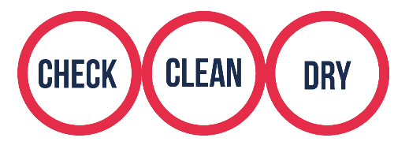

- CHECK boats, equipment, and clothing after leaving the water for mud, aquatic animals or plant material. Remove anything you find and leave it at the site. Reapply anti-fouling annually.

- CLEAN everything thoroughly as soon as you can paying attention to ropes, bilges, trailers, to the inside of your boat and areas that are damp and hard to access. Use hot water (at least 45ºC), steam or a high-pressure spray if you can.

- DRY - drain water from every part of your boat and trailer before leaving the site. Dry the surfaces of everything and allow to air dry for at least 48 hours – some species can live for many days or weeks in moist conditions.

  - Disinfect cleaned items if complete drying is not possible. Use disinfectant such as Virkon Aquatic, Virasure or any other proprietary disinfectant product. Areas difficult to dry can be sprayed or wiped down with disinfectant and where an outboard is used, the cooling system should be flushed out. For non-motorised craft such as canoes, kayaks and small sailing boats, where practical a disinfectant should be poured into the interior of the craft.
For boats that stay in the water year-round, lifting out, cleaning and antifouling annually (or as per product recommendation) keeps boat hulls clean, and has environmental benefits including both preventing the spread of invasive alien species and improving fuel efficiency. Apply antifoul everywhere on hull, check bow thrusters and intake and outlet pipes and anodes.
While you’re on the water you can reduce your risk of spreading invasive plants and animals by:
  - avoiding patches of floating plants (if possible)
  - removing any plants caught on your boat or props
  - if your boat has an inboard engine, clear weed filters and strainers regularly
  - bag up any plant material to bin later.
If you take your boat out of the water to move it somewhere new or move large distances between use and over wintering places, the boat should undergo cleaning before moving to make sure you don’t bring any invasive plants or animals with you.

Decision tree to help identify the biosecurity actions required
This diagram provides a quick reference guide to what biosecurity action must be taken in different scenarios, recognising some activities may be associated with higher biosecurity risk and that the ability to implement biosecurity actions may differ between activities. Use of the term boat in the diagram refers to all recreational watercraft.
START
Are you bringing a boat into Ireland or moving it within Ireland?
Moving boat within Ireland
Bringing boat to Ireland
PRINCIPLE: your boat should be free of any debris or organisms when moving to a new body of water (particularly new water catchment areas, harbours or marinas)
PRINCIPLE: your boat and equipment should be free of any debris or organisms when it enters Ireland

Do you always use your boat in the same water body/stretch of water?
How are you bringing the boat to Ireland?
By sea
Overland No Yes
ACTION: check, clean, and dry or disinfect your boat and equipment before entering Ireland
No specific biosecurity action required
How are you moving your boat?
Before entering Ireland, inspect your boat. How much hull fouling is there? *
By water
(i.e. sailing through canal network/coast hopping)
More than a slime layer
None or a slime layer
Overland

Before travelling check your boat. How much hull fouling is there? *
ACTION: check, clean and thoroughly dry your boat as soon as possible once it is out of the water
ACTION: you must lift and clean your boat before entering Ireland
ACTION: if a slime layer, you must lift and clean your boat or do in-water cleaning before entering Ireland
BE AWARE: your boat and trailer may be inspected at the border
BE AWARE: you may be required to clean your boat and trailer again before putting it in the water in Ireland
None or a slime layer
More than a slime layer

ACTION: you must lift and clean your boat before moving it
ACTION: if a slime layer, you must lift and clean your boat or do in-water cleaning
BE AWARE: your boat may be inspected on arrival to an Irish marina or canal

* Tip: regular maintenance will reduce the risk of heavy fouling. Other parts of boat/equipment also to be checked and cleaned.

Decision tree diagram adapted from the Recreational Boating Pathway Action Plan for Great Britain - www.nonnativespecies.org

Biosecurity measures per stakeholder level
Individual
Every boater should be undertaking the Check Clean Dry measures as part of a regular routine and certainly before bringing the craft into Ireland, a new waterbody, watercourse, catchment, or marina etc. When boats travel long distances, inspections are necessary and cleaning is recommended..
Club
Every club to adopt a biosecurity code of practice and promote and encourage use of biosecurity measures. Provide biosecurity resources and facilities where appropriate to members.
Marina and boat hire providers
Provide biosecurity cleaning facilities on site. Promote good biosecurity practices. Inspect facilities for biofouling and take action to remove or contain invasive alien species.
Organization
Adoption of an organization level biosecurity policy. Provision of biosecurity training and biosecurity awareness materials for clubs/members. Implement event risk mitigation measures.
All - emergency measures
When required, all to implement emergency biosecurity related measures. These measures will be determined on a case-by-case basis. As an example, pasted below are the Emergency Containment measures issued in response to Crayfish plague outbreaks in 2017:
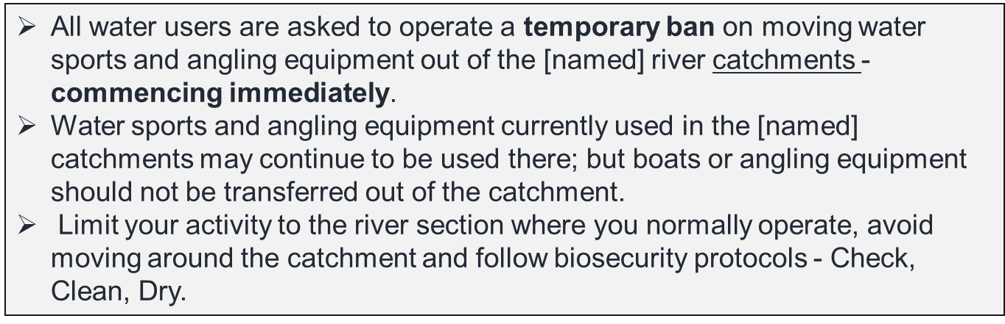
The Crayfish plague Emergency Containment Measures were issued in English, Hungarian, Polish and Czech. This temporary ban was lifted on March 1st, 2018 but with strong advice that all water users continue to exercise vigilance and adopt procedures to minimize the risk of further spread of the disease.

EU Code of Conduct on Recreational Boating and Invasive Alien Species – biosecurity guidance
The below more detailed guidance is taken directly from the EU Code of Conduct on Recreational Boating and Invasive Alien Species but these guidelines may be refined further under Ireland’s adaption of the Check, Clean, Dry biosecurity campaign.
‘More detailed tailored Check, Clean, Dry advice specific for recreational boating, particularly small trailered craft such as dinghies and RIBs is as follows:
On the water
- Avoid sailing or motoring through water plants and weed if possible. This can chop up plants and can spread them further. If caught up on the hull or propeller, invasive alien species can be transferred to another area.
- If the boat is on the water but not in use and stationery for a period of time, if possible, raise propellers out of the water to minimise the risk of invasive alien species entering the engine. Use your boat regularly to prevent biofouling of the hull and engine.
- If an anchor has been used, wash off both the anchor and chain before stowing.
- Any structures or equipment such as pontoons, piles and buoys which have been submerged in water for a time also pose a higher risk of spreading invasive alien species and so extra care should be taken when moving or working with them.
After use
- Once the boat is on shore, remove all visible plant and animal material and put in the bin.
- Use freshwater to wash down all parts of the boat that have been in contact with the water (including outboard, trailer and trolley/vehicle tyres). Pay attention to any crevices. Flush outboard engines with clean fresh water before leaving the site using appropriate equipment, flush muffs or in accordance with manufacturer’s recommendations.
- Drain all water from the boat, including bilges. Allow the water to drain completely from engines by placing them in a vertical down position.
- Wash and dry all equipment, clothing and footwear. Drying for as long as possible is important because some invasive alien species can survive for over two weeks in damp conditions.
- If freshwater washing facilities are not available on site, ensure that the boat is washed down, drained and dried prior to arrival at another waterbody.
- Ensure that any wash water run-off or water emptied from boats after use does not drain into another waterbody.
Many of the above actions are to target cleaning-off organisms and individuals not necessarily visible to the eye.
Boat storage on land
- Store boats and outboard engines in a location where any run-off does not drain into a waterbody (e.g. drains, gullies or rivers).
- Return any engines to their vertical down position to drain.
- Use the general waste bin to dispose of any plant or animal material found in prop bags or other equipment.
Antifouling and in-water cleaning
If boats, such as yachts and motor cruisers, are normally kept in the water for long periods of time the Check, Clean, Dry approach may not be a practical method of preventing the spread of aquatic IAS. Although biofouling may not necessarily always contain IAS, it follows that reducing biofouling minimises the risk of spread.
An appropriate antifouling coating system and good maintenance are the best way of preventing biofouling accumulation for boats kept on the water. Lifting out, cleaning and antifouling annually keeps boat hulls clean, and has environmental benefits including both preventing the spread of invasive alien species and also improving fuel efficiency. Different anti-fouling coating systems suit different operating profiles. An appropriate antifouling coating should be chosen by seeking expert advice and considering the time period between coatings, the use, location and type of the vessel and any legal requirements in the country of use.
It is important to note that antifoul may not be effective against all species in all areas, for example, some types of antifoul are thought to be ineffective against biofouling by zebra mussels (Weissert, 2013). Therefore, appropriate antifouling should be combined good maintenance, in-water cleaning and the Check, Clean, Dry approach where possible. The more a boat is used the less likely species will accumulate and the more effective any antifouling will be. By using the boat regularly over summer/growing season, the level of fouling can be reduced.
Antifouling is, by its nature, toxic to aquatic life. Since the banning of Tributyltin (TBT), most antifouls are now copper or zinc based. Available biocides are regulated by European and national regulations; however, during evaluation of these products, their toxicity should be balanced with their efficacy against biofouling, particularly by aquatic IAS. Some of the compounds found in these antifouls can enter the environment through leaching or during removal of the paint, accumulating in organisms, forming concentrated deposits in the sediments and finding their way into wildlife further up the food chain. Boat owners can play a vital role in preventing concentrated scrapings from entering the water by following the following best practice advice.
When removing antifoul:
- Select a marina, club or boatyard which has a wash-down facility which collects residues and captures run off from wash down, or prevent antifoul scrapings from entering the water by collecting in a tarpaulin;
- Use a dustless vacuum sander or wet abrasion to reduce dust toxic dust and to protect the users health;
- If using scrubbing piles, only scrub off the fouling and not the underlying paint – be careful not to let old or new paint enter the water
When applying antifoul:
- Select the right type of antifouling for the area and boat usage, choosing the lowest levels of biocides and copper suitable for your needs – take advice from the local chandlery. Use water-based paints where possible, or paints low in Volatile Organic Compounds or look into using less damaging bottom paints, such as vinyl, silicone or Teflon, which are suitable for in-water hull cleaning systems;
- Apply the right amount of antifouling required and do not spill it – when applying use a sheet to collect drips;
- Dispose of used brushes, rollers and trays and empty cans of antifoul as hazardous waste.
It is always preferable to clean boats out of the water where waste can be effectively captured for proper disposal. However, in-water cleaning can be effective as an interim measure.
In-water cleaning can be suitable for removing light fouling, predominantly if the boat has been in the water for less than a year but has not been frequently used and therefore may have accumulated biofouling. In-water should be done prior to moving the boat to another location or long-distance trips, if cleaning out of the water is not possible. This will help prevent invasive alien species from being transferred long distances, for example from one country to another. Remove any potential invasive alien species in situ at a home harbour before transferring them somewhere else.
Before undertaking any in-water cleaning, check with the local authorities for any regulations regarding the in-water cleaning of boat hulls and/or the discharge of chemicals into the water column. In-water cleaning systems are available in some marinas, or the process can be carried out by hand:
- Use gentle techniques to minimize both the release of toxic substances from any anti-fouling coating and the degradation of the anti-fouling coating system;
- Take care not to deplete the anti-fouling coating system which would then rapidly re-foul: in-water should not be used in order to delay haul-out beyond the specified service life of a coating. Many inland water recreational boats (narrow boats, motor cruisers and barges) do not have any anti-fouling coating - thus there is a reduced risk of toxicity for aquatic life from cleaning the hull in these cases;
- From a tender, a sponge can be used to clean as much material off as possible. Alternatively, use a long handled brush from the pontoon or the boat to clean off the material;
- Collect the material into a bucket or bag for disposal on land where practical.’

The EU Code of Conduct on Recreational Fishing and Invasive Alien Species notes that ‘where recreational fishers and fisheries use boats or float tubes for angling purposes then in addition to the above:
• Biofouling must be thoroughly removed from all hulls and other submerged surfaces before transfer to another site.
• Care should be taken with trailers which have cavities that may retain water and be hard to inspect. If possible, trailers and launching trolleys should be provided at the site and used in preference to personal equipment.
• Any water that collects in bilges or inside boats and float tubes must be completely emptied before leaving the site.
• Water cooled engines must be washed through with tap water to ensure the system does not harbour invasive alien species.’
Paddle sports
Detailed guidance taken from the Inland Fisheries Ireland Disinfection of Paddle Sports Equipment leaflet. Produced March 2014. Available online: www.fisheriesireland.ie/Biosecurity/biosecurity-for-boaters-and-anglers.html
Following each trip, all paddle sports equipment should be routinely inspected, disinfected and thoroughly dried out. Items of paddle sports equipment that might require attention include:
- Canoes, kayaks, stand-up paddle boards, clothing including wet suites, cags, personal floatation devices, spray skirts, helmets, leashes and paddles.
Prior to leaving any location following a trip you should:
- Drain water from watercraft
- Inspect watercraft (inside and out) and other gear. Remove sand safely dispose of all attached plant and animal material, mud or debris.
- Spray or clean watercraft with disinfectant or power-hose with heated water (60ºC).
- Rinse and Dry all gear thoroughly
- Where practicable, a volume of disinfectant should be poured into the watercraft and gear disinfected by immersion using a 1% solution of Virkon ®Aquatic or other proprietary disinfectant with a contact time of at least 15 minutes.

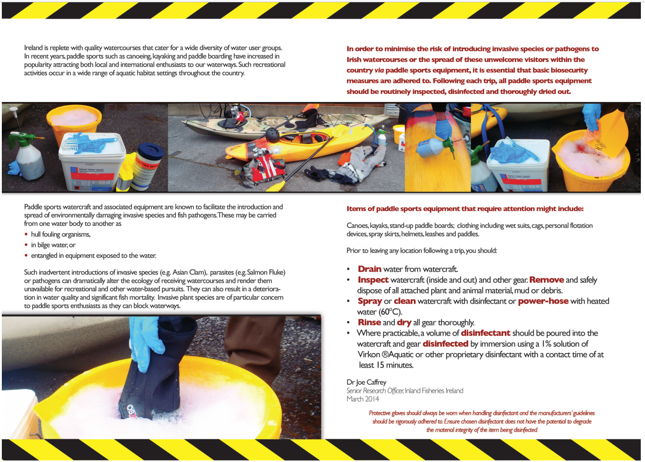
Additional aquatic biosecurity reference materials:
Check Clean Dry aquatic biosecurity campaign awareness materials are available to download from the National Biodiversity Data Centre’s website on invasive species https://invasives.ie/biosecurity/check-clean-dry/. Materials may also be available on sporting organisation websites.
Inland Fisheries Ireland biosecurity campaign for boaters and anglers: https://www.fisheriesireland.ie/Biosecurity/biosecurity-for-boaters-and-anglers.html
and for scuba divers:
https://www.fisheriesireland.ie/Biosecurity/invasive-species-biosecurity-guidelines-for-scuba-diving.html
Council of Europe. European Code of Conduct on Recreational Boating and Invasive Alien Species. Strasbourg, 2016. Prepared by Ms Emma Barton, European Boating Association, on behalf of the Bern Convention. https://rm.coe.int/1680746815

Appendix III - Priority concern DRAFT list of invasive alien species

List of freshwater, marine and pathogen species of priority concern to keep out of Ireland and for which there may be a risk of introduction via recreational boating and watersport activities.
Some species are currently present in Ireland and/or Northern Ireland but several more are present and widespread in Great Britain and mainland Europe.
Freshwater
Scientific name | Common name | Taxon Group | Present in Ireland | Note
All non-native crayfish | Including: Signal crayfish; Virile crayfish; Rusty crayfish; Spinycheek crayfish; Noble crayfish; Turkish crayfish | Crayfish | No | Localised population of Yabby  (Cherax destructor)
Alternaterna philoxeroides | Alligator weed | Plant | No
Barbus barbus | Barbel | Fish | No
Corbicula fluminea | Asian clam | Mollusc | Yes | In Shannon catchment
Dikerogammarus haemobaphes | Demon shrimp | Amphipod | No
Dikerogammarus villosus | Killer shrimp | Amphipod | No
Dreissena rostriformis bugensis | Quagga mussel | Mollusc | Yes | In Shannon catchment
Eriocheir sinensis | Chinese mitten crab | Crab | Yes | Localised
Hydrocotyle ranunculoides | Floating pennywort | Plant | Yes | Localised and under eradication at one pond site
Ludwigia grandiflora & Ludwigia peploides | Water primrose | Plant | Yes | Localised
Neogobius melanostomus | Round goby | Fish | No
Perccottus glenii | Amur sleeper | Fish | No
Pseudorasbora parva | Topmouth gudgeon; Stone moroko | Fish | No
Salvelinus fontinalis | Brook trout; Brook charr; Sea trout | Fish | No
Sander lucioperca | Zander; Pikeperch | Fish | No
Squalius cephalus | Chub | Fish | Yes | Localised
Thymallus thymallus | Grayling | Fish | No

Marine
Scientific name | Common name | Taxon Group | Present  in Ireland | Note
Caulacanthus okamurae | pom-pom weed | Macroalgae (seaweed) | No
Celtodoryx ciocalyptoides | sponge | Sponge | No
Cercopagis pengoi | Fishook waterflea | Crustacean | No
Didemnum vexillum | Ascidian species | Tunicate | Yes | Localised
Gracilaria vermiculophylla | A red macroalgae (seaweed) | Macroalgae (seaweed) | No
Hemigrapsus sanguineus | Asian shore crab | Crustacean | No
Hemigrapsus takanoi | Brush-clawed shore crab | Crustacean | No
Hesperibalanus fallax | warm-water barnacle | Crustacean | No
Mnemiopsis leidyi | Warty comb-jelly; Sea Walnut | Ctenophore (a stingless jellyfish-like animal) | No
Rapana venosa | Veined rapa whelk | Mollusc | No
Undaria pinnatifida | Wakame; Japanese kelp | Macroalgae (seaweed) | Yes | Localised

Pathogens
Scientific name | Common name | Field characteristics | Reference
Salmon isavirus | Infectious salmon anaemia  (ISA) virus | Fish behave lethargically and swim near the surface, often vertically when gasping, and are reluctant to feed. Symptoms include a distended abdomen, protruding bloodshot eyes and pale swollen gills. Symptoms normally develop slowly. | D. Minchin. (2014) Risk Assessment of non-indigenous aquatic Species, Ireland. Report undertaken for the Northern Ireland Environment Agency
Aphanomyces astaci | Crayfish plague disease | Many dead or dying White-clawed crayfish  (Austropotamobius pallipes) – a native species. The dead crayfish may be seen upside-down in the water. | https://invasives.ie/species-alerts/crayfish-plague
Gyrodactylus salaris | Salmon fluke | Specialist knowledge needed. Heavily infected fish normally have damaged fins, in particular the dorsal, caudal and pectorals and there may be copious mucus production. Infested fish are normally lethargic. | D. Minchin. (2014) Risk Assessment of non-indigenous aquatic Species, Ireland. Report undertaken for the Northern Ireland Environment Agency
Note: Report suspected cases of these diseases to the Fish Health Unit of the Marine Institute

Invasive alien species established in Ireland - undertaking biosecurity measures can help reduce the risk of their spread to new sites.
Scientific name | Common name(s) | Environment
Lagarosiphon major | African curly waterweed; Lagarosiphon | Freshwater
Myriophyllum aquaticum | Parrott's feather | Freshwater
Elodea nuttallii | Nuttall's waterweed | Freshwater
Crassula helmsii | New Zealand pigmyweed | Freshwater
Lysichiton americanus | American skunk cabbage | Riparian
Gunnera tinctoria | Giant rhubarb; Chilean rhubarb | Riparian
Impatiens glandulifera | Himalayan balsam; Indian balsam | Riparian
Fallopia japonica; Fallopia x bohemica; Fallopia sachalinensis; Persicaria wallichii | Japanese knotweed and other  invasive knotweeds | Riparian
Sargassum muticum | Japanese wireweed | Marine
Styela clava | Leathery Sea Squirt | Marine

The listing of these species as priority concern alert species is due to them being assessed and ranked at high risk of being invasive should they arrive and establish in Ireland.
The listing of these priority concern alert species may change if the threat status of listed or unlisted species changes or on review of the list by the Aquatic Invasive Alien Species and Biosecurity Technical Advisory Group. An up-dated version of the species list will be maintained on the National Biodiversity Data Centre’s invasive species website: https://invasives.ie/biosecurity/pathway-action-plans/
Some of the species listed in this section plus many more are regulated under European and domestic regulations for prohibition on introduction, keeping and dispersal. For more information and to view the lists of regulated species visit: https://invasives.ie/about/irelands-invasive-species/.

Reporting sightings of invasive alien species
Report suspected sightings of invasive alien species to the National Biodiversity Data Centre through the Biodiversity Data Capture app (available on ios and android) or through the online recording form: https://records.biodiversityireland.ie/record/invasives
Provide a photograph, if possible, to aid verification of the species identity.

Appendix IV – Check Clean Dry biosecurity campaign awareness resources

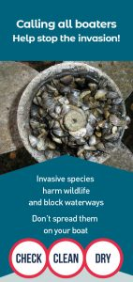
Contaminated fishing gear, boats and equipment can cause the spread of invasive species to new water bodies. Invasive plants and animals can be small and hard to spot, and they can survive for weeks on damp gear and equipment. Anglers and other water users can help protect the environment and sport they enjoy by remembering to Check, Clean and Dry their angling gear, boats and equipment when moving between waterbodies. A range of biosecurity awareness raising materials are freely available to you and your club, outlining the key steps to take to reduce the risk of spreading invasive species.

You can download these free materials for your club or event to protect our environments and to be a part of the Check, Clean, Dry campaign from https://invasives.ie/biosecurity/check-clean-dry/. Some of the materials are shown here.
If you require high quality print ready versions of any of the materials, please e-mail the National Biodiversity Data Centre: invasives@biodiversityireland.ie

Regarding Action 4 - Check Clean Dry logo with web link for display with licences/permits
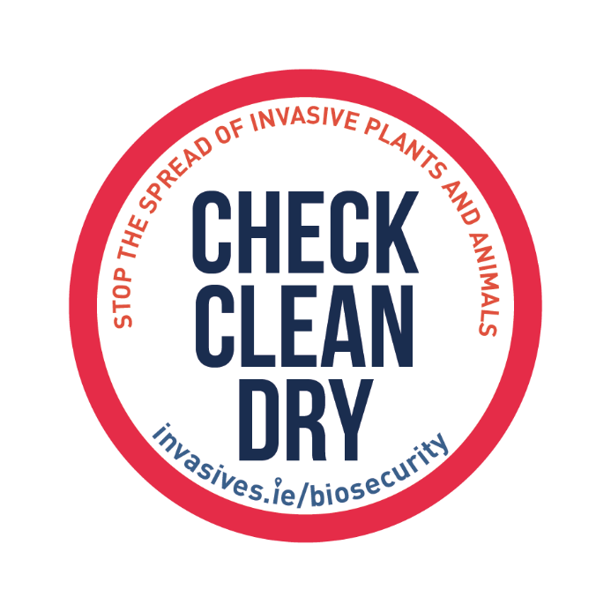

Regarding Actions - Biosecurity signage
Outdoor sign and poster available to download in English and Irish language
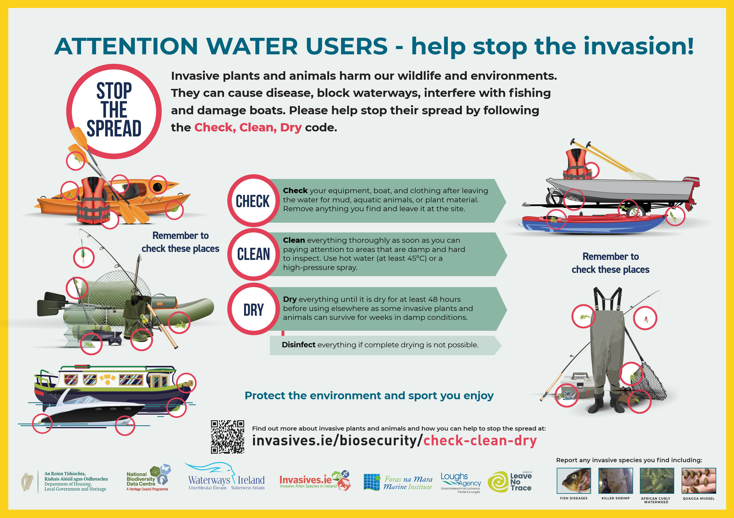
Sign/poster for Water Site Manager
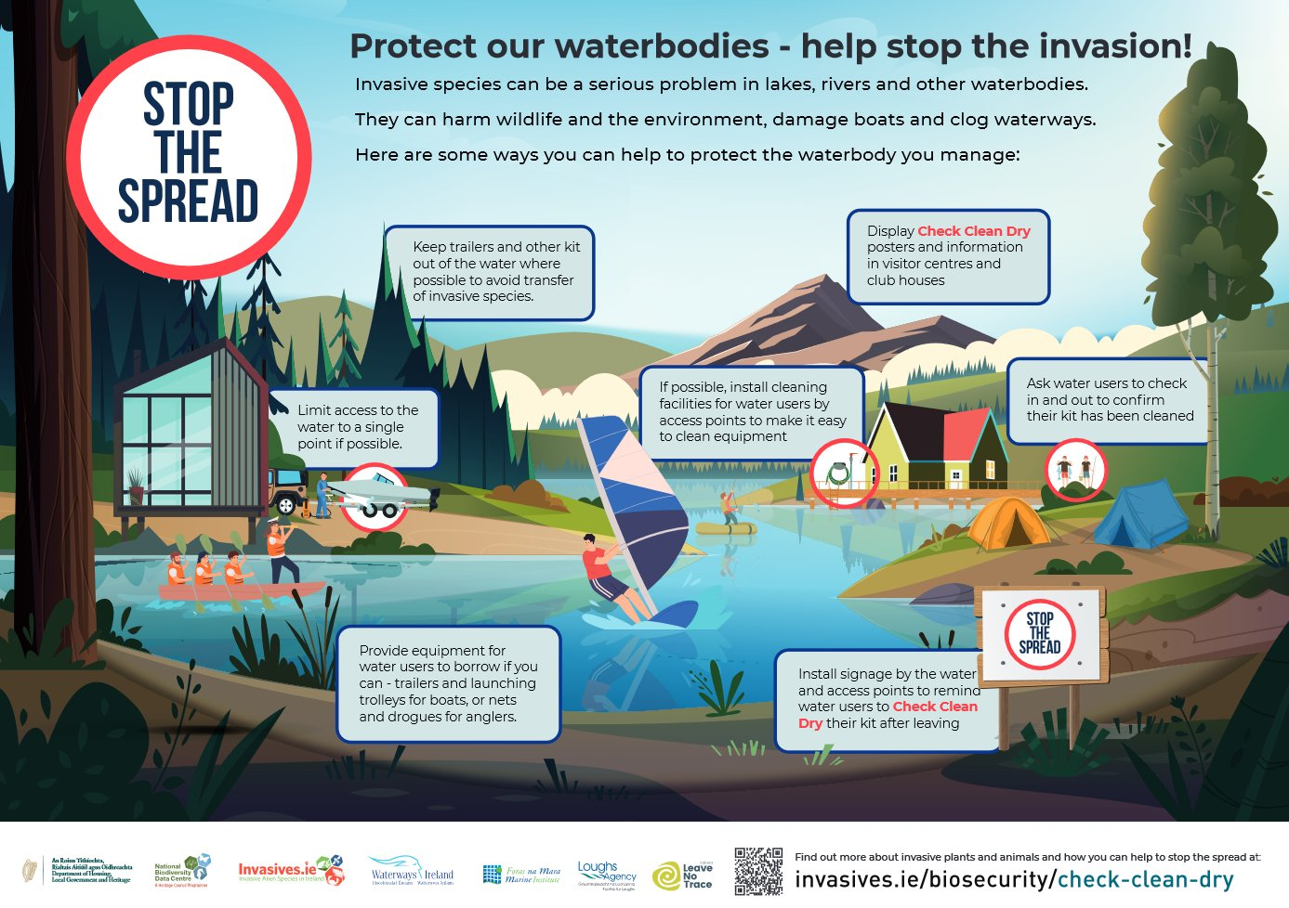
General boating biosecurity awareness poster. Versions of this are also available for canal boating, marine boating and paddle sports

Templates available to show your support of the aquatic biosecurity Check Clean Dry campaign by adding your own organisation name and displaying as a poster or sign in your area.

For information on Ireland’s Invasive Alien Species Recreational Boating and Watercraft Pathway Action Plan 2022 – 2027 contact:

National Parks and Wildlife Service
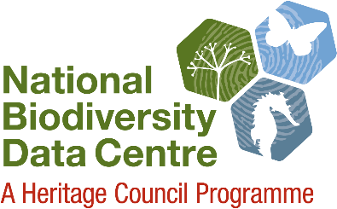
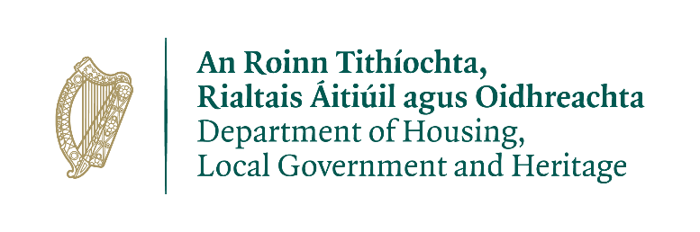
Biodiversity Policy, 90 North King Street, Dublin 7, Ireland
E-mail: natureconservation@housing.gov.ie
Phone: +353 (0)1 8883200
Or
National Biodiversity Data Centre
Carriganore, Waterford, Ireland
E-mail: invasives@biodiversityireland.ie
Phone: +353 (0)51 306240

Council of Europe. European Code of Conduct on Recreational Boating and Invasive Alien Species. Strasbourg, 2016. Prepared by Ms Emma Barton, European Boating Association, on behalf of the Bern Convention.
The official title of the EU Invasive Alien Species Regulation is: Regulation (EU) No 1143/2014 of the European Parliament and of the Council of 22 October 2014 on the prevention and management of the introduction and spread of invasive alien species.
O’Flynn, C., Kelly, J., Lysaght, L. (2014). Ireland’s invasive and non-native species – trends in introductions. National Biodiversity Data Centre Series No. 2. Ireland.
The term ‘biosecurity’ relates to measures taken to prevent the introduction and spread of living organisms.
H.B. Feeley et al. (2014-W-LS-5). Irish Freshwater Resources and Assessment of Ecosystem Services Provision EPA Research Report. Available online: www.epa.ie/pubs/reports/research/water/EPA%20RR%20207%20final%20web-2.pdf
A Survey of Marine and Coastal Overseas Tourism Activity in Ireland. 2019. Socio-Economic Marine Research Unit (SEMRU). Available online: http://www.nuigalway.ie/media/researchsites/semru/files/SEMRU-Overseas-Marine-Tourism-Report-Final1.pdf
A Survey of Domestic Coastal and Marine Tourism and Leisure Activity in Ireland. 2020. Socio-Economic Marine Research Unit (SEMRU). Available online: https://www.nuigalway.ie/media/researchsites/semru/files/FINAL_Tourism_Domestic_report.pdf
National Marine Planning Framework Baseline Report. September 2018. Available online: https://www.housing.gov.ie/sites/default/files/publications/files/national_marine_planning_framework_baseline_report.pdf
Waterway Users Research Report 2017. Available online: https://www.waterwaysireland.org/Documents/Research/Waterway%20Users%20Research%202017.pdf
National Marine Planning Framework Baseline Report - Irish Marine Federation Submission and Response. December 2018. Available online: https://www.housing.gov.ie/sites/default/files/public-consultation/files/responses/106_irish_marine_federation.pdf
Inland Fisheries Ireland (2015). The Economic Contribution of Bass and Sea Angling in Ireland.
National Marine Planning Framework Consultation Draft. Year of publication unknown but circa 2019/2020. Dept. Housing, Planning and Local Government. Available online: www.housing.gov.ie/sites/default/files/public-consultation/files/draft_national_marine_planning_framework_final.pdf
Inland Fisheries Ireland (2015). National Strategy for Angling Development (NSAD) 2015-2020
Full title: The Shannon Mighty River of Ireland A Tourism Masterplan for the Shannon 2020 – 2030 Reimagining the River Shannon and Shannon Erne Waterway. Available from: https://online.flippingbook.com/view/569022/ Waterways Ireland, in association with Fáilte Ireland and with the support of the ten local authorities adjoining the River Shannon and Shannon Erne Waterway: Leitrim, Cavan, Roscommon, Longford, Westmeath, Galway, Offaly, Tipperary, Clare and Limerick developed this plan.
The Shannon Mighty River of Ireland A Tourism Masterplan for the Shannon 2020 – 2030 Reimagining the River Shannon and Shannon Erne Waterway. Available from: https://online.flippingbook.com/view/569022/
https://www.coe.int/en/web/bern-convention
https://eur-lex.europa.eu/legal-content/EN/TXT/?uri=CELEX%3A32007R0708
https://revisedacts.lawreform.ie/eli/1976/act/39/revised/en/html
www.irishstatutebook.ie/eli/2000/act/38/enacted/en/print.html
www.irishstatutebook.ie/eli/2011/si/477/made/en/print
www.irishstatutebook.ie/eli/2011/si/249/made/en/print
ww.npws.ie/sites/default/files/publications/pdf/National%20Biodiversity%20Action%20Plan%20English.pdf
www.npws.ie/news/biodiversity-climate-change-sectoral-adaptation-plan
http://ec.europa.eu/environment/marine/eu-coast-and-marine-policy/marine-strategy-framework-directive/index_en.htm
https://ec.europa.eu/environment/water/water-framework/index_en.html
www.catchments.ie/significant-pressures-invasive-species/
Guidance for Minimizing the Transfer of Invasive Aquatic Species as Biofouling (hull fouling) for Recreational Craft. 2012. International Maritime Organization.
Various Inland Fisheries Ireland biosecurity guidance booklets available from: www.fisheriesireland.ie/Biosecurity/biosecurity.html
Recommended Guidelines for Event Participants and Support Crew. Irish Sailing. Available online: www.sailing.ie/Our-Environment
Council of Europe. European Code of Conduct on Recreational Boating and Invasive Alien Species. Strasbourg, 2016. Prepared by Ms Emma Barton, European Boating Association, on behalf of the Bern Convention. https://rm.coe.int/1680746815
Council of Europe. Recommendation Nº170 (2014) on the European Code of Conduct on Recreational Fishing and Invasive Alien Species. Strasbourg, 5 December 2014. https://bit.ly/3o57gLd
Source references include: Lucy, F. et al. (2020) Horizon scan of invasive alien species for the island of Ireland. Management of Biological Invasions 11(2): 155–177, https://doi.org/10.3391/mbi.2020.11.2.01 D. Minchin. (2007) Rapid coastal survey for targeted alien species associated with floating pontoons in Ireland. Aquatic Invasions Volume 2, Issue 1: 63-70 D. Minchin. (2014) Risk Assessment of non-indigenous aquatic Species, Ireland. 10 December 2014. Report undertaken for the NIEA by D. Minchin. Kelly, J., O’Flynn, C., and Maguire, C. 2013. Risk analysis and prioritisation for invasive and non-native species in Ireland and Northern Ireland. A report prepared for the NIEA and the NPWS as part of Invasive Species Ireland. Roy, H. et al. (2014) Horizon scanning for invasive alien species with the potential to threaten biodiversity in Great Britain. Global Change Biology 20: 3859–3871, https://doi.org/10.1111/gcb.12603 WFD UK Tag. Classification of aquatic alien species according to their level of impact. Working Paper Version: 8 (29/01/2021)

