WILDLIFE ACTS 1976 TO 2018 – SECTIONS 36
APPLICATION FOR LICENCE TO HUNT USING A MECHANICALLY PROPELLED VEHICLE
FOR EDUCATIONAL, SCIENTIFIC OR OTHER PURPOSES

[PLEASE USE BLOCK LETTERS]
1. Name of applicant:
Address:
Town
County
 |  |  |  | Eircode:
Telephone No.: |  |  |  | Email address:
2. Species Name: (Common & Scientific)
3. Area(s) in which applicant will operate:
(detailing townland and county).

4. State the reason(s) that you are seeking a licence
5. Do you intend to use a lamp?
6. Period for which licence is required:
7. Number of previous licence (if any) and date of expiry:
I declare that the above particulars are, to the best of my knowledge and belief, true and correct.
Signature: ……………………………………………………………… |  |  |  |  |  | Date: ……………………………………..
Please return completed  application form to:  Wildlife Licensing Unit (R. 2.03)  National Parks & Wildlife Service  90 King Street North  Smithfield  Dublin 7  D07 N7CV  Email: wildlifelicence@housing.gov.ie |  |  |  |  | 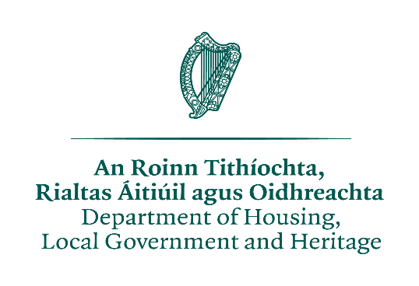

License application under the Wildlife Act 1976 to 2018
PRIVACY STATEMENT

Please note that under Data Protection legislation Department staff may only discuss licence applications with the applicant, and not with any third party. See Privacy Statement at www.npws.ie/licences

