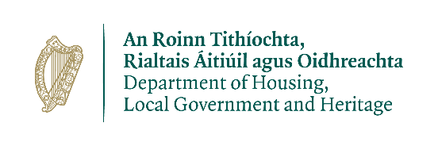

Wildlife Acts 1976 TO 2018 –
Section 23(6) (c)
Application for a 12 Month Licence to Possess Injured or Disabled Protected Wild Animals

Prepared by the Department of Housing, Local Government and Heritage
npws.ie

- This application to be completed by applicants seeking a 12 month licence to possess injured or disabled protected wild animals.
- Please use legible BLOCK LETTERS and answer ALL questions.
- To avoid unnecessary delay in processing your application, please ensure that you have fully completed this form and that you have included a current email address.
Please return your completed forms by email or post:
Email: wildlifelicence@housing.gov.ie
Post: Wildlife Licensing Unit
National Parks and Wildlife Service
Department of Housing, Local Government and Heritage
90 North King Street
Smithfield
Dublin 7, D07 N7CV

Privacy Statement
Please note that under Data Protection legislation Department staff may only discuss licence applications with the applicant, and not with any third party. See Privacy Statement at www.npws.ie/licences

Part 1: Personal Details
Applicant/Organisation Name: _______________________________________
Address Line 1
Address Line 2
County
Eircode
Daytime Phone No.
Email Address
Role in Organisation

Part 2: Organisation Details
Person in Charge of Organisation
Is your Organisation a registered charity? |  |  | Yes |  | No
If Yes – please provide Charity Number

How is Your Organisation Structured: E.g. Board/Directors/Individuals?

How long has the Organisation/Individual being in operation
Description of Organisation’s Facilities: (use extra paper if needed)

Qualifications/Experience in this field of activity of all individuals involved in animal possession and rehabilitation

Have you held previous licences (individual/collective): Yes No
If yes please provide details:
Have you a qualified vet on site? |  | YES_________ NO__________
If yes – please provide name and full details
Vet’s Name:
Address of Practice:
Are you affiliated to another organisation? |  | YES_________ NO__________
If Yes – please provide details

Do you hold a Zoo Licence? |  | YES_________ NO__________
If Yes – please provide details of your licence
Part 3: CITES Information

Are any of the Animals in your care covered by CITES Regulations?
If Yes – please provide details including species name and EC Annex if known

Part 4: Licence Requirements

Date from which licence is required:

Description of types of animals to be possessed for rehabilitation purposes under this licence:

Part 5: Declaration
I declare that all of the foregoing particulars are, to the best of my knowledge and belief, true and correct.

Signature Of Applicant:_______________________ Date: ___ / ___ / ______
Any person who, for the purposes of obtaining a licence under the Wildlife Acts 1976 to 2018 makes any statement or gives information which they know to be false shall be guilty of an offence.
npws.ie
Department of Housing, Local Government and Heritage

