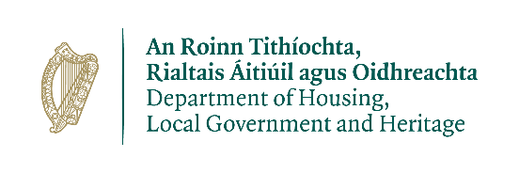

Wildlife Acts 1976 TO 2018 –
Section 23(6) c)
Application for a Licence to Possess an Injured or Disabled Protected Wild Animal

Prepared by the Department of Housing, Local Government and Heritage
npws.ie

- This application to be completed by applicants seeking a licence to possess a disable or injured Wild Animal.
- Please use legible BLOCK LETTERS and answer ALL questions.
- To avoid unnecessary delay in processing your application, please ensure that you have fully completed this form and that you have included a current email address.
Please return your completed forms by email or post:
Email: wildlifelicence@housing.gov.ie
Post: Wildlife Licensing Unit
National Parks and Wildlife Service
Department of Housing, Local Government and Heritage
90 North King Street
Smithfield
Dublin 7, D07 N7CV

Privacy Statement
Please note that under Data Protection legislation Department staff may only discuss licence applications with the applicant, and not with any third party. See Privacy Statement at www.npws.ie/licences

Part 1: Personal Details
Name __________________________________________________________
Address Line 1
Address Line 2
County
Eircode
Daytime Phone No.
Email Address
Qualifications / Experience in this field of activity

Are you affiliated to an Organisation? |  | Yes |  | No
If Yes – please provide details
Part 2: Details of Animal:
Species
Age: (If Known)
Gender
Name, Address and Contact Number of Person who found the animal
Location and Date Found

Description of Injuries

Was the animal examined by a Vet? Yes No
If yes, please provide vet details and report:

If no, please give a reason as to why this specimen was not referred to a vet

Period for which licence is required: __________________________

Part 3: Declaration
I declare that all of the foregoing particulars are, to the best of my knowledge and belief, true and correct.
Signature Of Applicant:_______________________ Date: ___ / ___ / ______
Any person who, for the purposes of obtaining a licence under the Wildlife Acts 1976 to 2018 makes any statement or gives information which they know to be false shall be guilty of an offence.
npws.ie
Department of Housing, Local Government and Heritage

