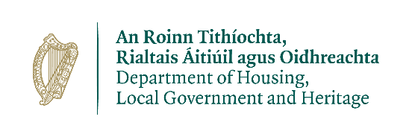

Wildlife Acts 1976 TO 2018 –
Section 23(6) (d)
Application for a Licence to Retain an Injured or Disabled Protected Wild Animal

Prepared by the Department of Housing, Local Government and Heritage
npws.ie

- This application to be completed by an applicant who is seeking a licence to retain an injured or disabled protected Wild Animal
- Please use legible BLOCK LETTERS and answer ALL questions.
- To avoid unnecessary delay in processing your application, please ensure that you have fully completed this form and that you have included a current email address.
Please return your completed forms by email or post:
Email: wildlifelicence@housing.gov.ie
Post: Wildlife Licensing Unit
National Parks and Wildlife Service
Department of Housing, Local Government and Heritage
90 North King Street
Smithfield
Dublin 7, D07 N7CV

Privacy Statement
Please note that under Data Protection legislation Department staff may only discuss licence applications with the applicant, and not with any third party. See Privacy Statement at www.npws.ie/licences

- Personal Details
Name __________________________________________________________
Address Line 1
Address Line 2
Address Line 3
County
Eircode
Daytime Phone No.
Email Address
Part 2: Details of Animal:
Species:
Age: (If Known):
Gender:
Name and Address of Person who found the bird:
Location and Date Found:

Possession Licence No:
Description of Injuries

Was the animal examined by a Vet?  If not, please give reasons as to why it has not been examined |  | Yes No
Veterinarian’s Name and Address of Practice

Outcome of Examination

Should the Animal be Euthanised? | Yes No
If No – Why (Please provide details as to why the Animal should be retained)

Veterinarian’s Signature
Before a licence can be issued – a Veterinary examination must take place to certify that the animal is incapable of being returned to the wild following rehabilitation.

Part 3: CITES Information
Is the Animal on the CITES Annexes or on any of the Annexes to the Birds and Natural Habitats Regulations? | ID Number  (Microchip or other identifier) |  | CITES Appendix, EC Annex or BNH Regulations Annex | Species Name
Yes_____ No_____
Part 4: Further Details on Retaining Animal
Details on why the animal cannot be returned to the Wild (Please provide details (Including Veterinarian’s Report)

Holding Facility Location and Details

Will this specimen be used commercially for breeding or display? |  | Yes No
Details of Breeding, Research or Educational Project
Part 5: Declaration
I declare that all of the foregoing particulars are, to the best of my knowledge and belief, true and correct.
Signature Of Applicant:_______________________ Date: ___ / ___ / ______
Any person who, for the purposes of obtaining a licence under the Wildlife Acts 1976 to 2018 makes any statement or gives information which they know to be false shall be guilty of an offence.
npws.ie
Department of Housing, Local Government and Heritage

