WILDLIFE ACTS 1976 TO 2018 – SECTION 22(9)(f)

APPLICATION FOR A LICENCE TO PHOTOGRAPH/ FILM A PROTECTED WILD BIRD

[PLEASE USE BLOCK LETTERS]
1. Name of applicant:
Address:
Town/County
Eircode:
Telephone No.: |  |  |  | Email Address:
2. Species Name:
3. Purpose of filming or photography:
4. State whether licence is for filming
or photography:
5. Area(s) in which applicant will
operate: (e.g. county and townland)
6. Qualifications/experience in this field of activity
7. Organisation to which applicant is affiliated:
8. Period for which licence is required:
9. Number of previous licence (if any) and date of expiry:
**N.B. Where necessary attach any additional relevant information.**
I declare that the above particulars are, to the best of my knowledge and belief, true and correct.
Signature: ………………………………………………………… |  |  |  |  |  | Date: ……………………………………..
Please return completed  application form to:  Wildlife Licensing Unit (R. 2.03)  National Parks & Wildlife Service  90 King Street North  Smithfield  Dublin 7  D07 N7CV  Tel.: (01) 888 2000  Email: wildlifelicence@npws.gov.ie |  |  |  |  | 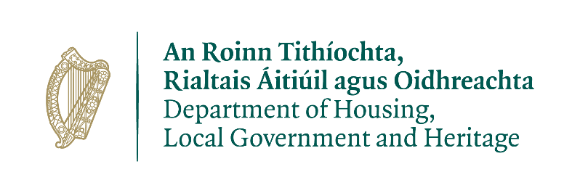

Please note that under Data Protection legislation Department staff may only discuss licence applications with the applicant, and not with any third party. See Privacy Statement at www.npws.ie/licences

