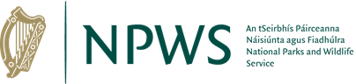

Wildlife Acts 1976 TO 2018
Section 41
Application for Bird of Prey Licence(s) for use by Out of State Applicants (Including Northern Ireland)

Prepared by the National Parks and Wildlife Service
npws.ie

- This application to be completed by all applicants.
- Please use legible BLOCK LETTERS and answer ALL questions.
- To avoid unnecessary delay in processing your application, please ensure that you have fully completed this form and that you have included a current email address.
Please return your completed forms by email or post:
Email: wildlifelicence@npws.gov.ie
Post: Wildlife Licensing Unit
National Parks and Wildlife Service
Department of Housing, Local Government and Heritage
90 King North Street
Smithfield
Dublin 7,
D07 N7CV

Privacy Statement
Please note that under Data Protection legislation Department staff may only discuss licence applications with the applicant, and not with any third party. See Privacy Statement at www.npws.ie/licences

- Personal Details
Full Name: ________________________________________________________
Address Line 1
Address Line 2
Postcode
Country
Daytime Phone No.
Email
Age (If Under 18)
Are you a first time applicant? |  | Yes |  | No
If No – please provide details of previous licence number
If Yes – please provide details of experience/training

PAYMENTS CAN BE MADE DIRECTLY INTO THE DEPARTMENT’S BANK ACCOUNT

The details of this Department’s Danske bank account is as follows:

Company Name: Department of Housing, Local Government & Heritage
Account Name: PMG Receipts – Public Bank Account
BIC: DABAIE2D
IBAN: IE30DABA95159980001341

Part 2A.
Birds that will be flown in the Republic of Ireland
Species | Age | Sex | Ring Number | Microchip Details

Part 2B.
Dates and Locations within the Republic of Ireland where/when you intend visiting/flying birds
Date(s) you will visit the Republic of Ireland | Location(s) you will be flying your birds

Please enclose copies of the following documents with your application:

- Proof of Ownership and/or CITES/Article 10 Certificates.
These documents are required for all birds to be flown in the Republic of Ireland.

Part 3. Declaration
I declare that all of the foregoing particulars are, to the best of my knowledge and belief, true and correct.

Signature Of Applicant:_______________________ Date: ___ / ___ / ______
Any person who, for the purposes of obtaining a licence under the Wildlife Acts 1976 to 2018 makes any statement or gives information which they know to be false shall be guilty of an offence. Penalties, on conviction include fines and forfeiture of firearms.

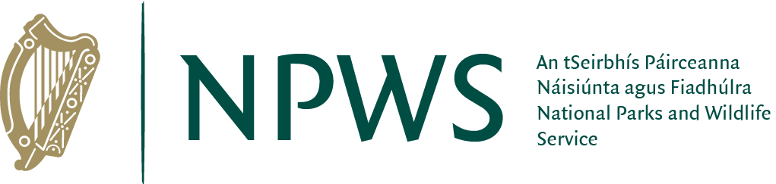
npws.ie
National Parks and Wildlife Service

