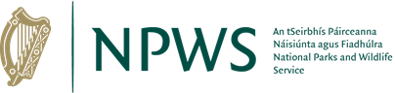

Wildlife Acts 1976 – As Amended
Section 32
APPLICATION FOR LICENCE TO RING OR MARK ANY WILD ANIMAL

Prepared by the National Parks and Wildlife Service
npws.ie

- All fields are mandatory and must be completed.
- Please use legible BLOCK LETTERS.
- To avoid unnecessary delay in processing your application, please ensure that you have fully completed this form with the correct details and you have included a current email address. All previous licence holders should ensure that end of year totals have been submitted using the relevant returns form.
- Please read the Section 32 guidance document before completing this application.

Please return your completed forms by email:
Email: wildlifelicence@npws.gov.ie

Privacy Statement
Please note that under Data Protection Legislation Wildlife Licencing Unit staff may only discuss licence applications with the applicant, and not with any third party. See Privacy Statement at www.npws.ie/licences
- Personal Details
Full Name: Click or tap here to enter text.
Address Line 1 | Click or tap here to enter text.
Address Line 2 | Click or tap here to enter text.
Address Line 3 | Click or tap here to enter text.
County | Click or tap here to enter text.
Eircode | Click or tap here to enter text.
Phone No. | Click or tap here to enter text.
Email | Click or tap here to enter text.
Organisation Name – if applicable | Click or tap here to enter text.
Address of Organisation  (Include Eircode) | Click or tap here to enter text.

Part 2. Licence Details
Please indicate details to appear on the licence.
If you are a Trainer, please list the Trainees to be included on your licence. Licence holders should submit a Returns Form.
Click or tap here to enter text. |  | Click or tap here to enter text.
Click or tap here to enter text. |  | Click or tap here to enter text.
Click or tap here to enter text. |  | Click or tap here to enter text.
Period for which licence is required (include start/end date) | Start:Click or tap to enter a date.  End:Click or tap to enter a date.
Have you held a licence before? If so please provide Licence No. | Click or tap here to enter text.
All End of Year Totals (Returns Form) must be submitted on expiry of licence to wildlife.reports@npws.gov.ie prior to new licence being granted.

Part 3. Species Name and Numbers
Please indicate the name of the species (Common & Scientific) and the estimated number to be processed under this licence.
Click or tap here to enter text. | Click or tap here to enter text.
Click or tap here to enter text. | Click or tap here to enter text.
Click or tap here to enter text. | Click or tap here to enter text.

Part 4. Proposed activity to be carried out under this licence
For what purpose do you require this licence?
Click or tap here to enter text.

Part 5. Area/s in which applicant will operate
Please indicate the area/s in which applicant will operate? This should include County. Please note maps may be requested.
Click or tap here to enter text.
Click or tap here to enter text.
Click or tap here to enter text.

Part 6. What are the proposed means of taking
Please give details on how you intend to take. Please tick as many as relevant.
Net | ☐
Trap | ☐
Other Means | ☐
Provide Details of the Net/Trap or Other Means:
Click or tap here to enter text.

Part 7. Type of Marking or Ringing Device
Please give specific details of the type of marking or ringing device you intend to use. Please tick as many as relevant.
Band | ☐
Ring | ☐
Microchip | ☐
Tag | ☐
Other Marking Device | ☐
Provide Details on the Marking Device Being Employed:
Click or tap here to enter text.

Part 8. Qualifications/Experience in this field of activity
Please outline your relevant qualifications/experience.
Click or tap here to enter text.
Click or tap here to enter text.
Click or tap here to enter text.

Part 9. Declaration
I declare that all particulars as set out in this application form under Section 32 of the Wildlife Act 1976 – as amended are correct to the best of my knowledge and belief, and I apply for a licence in accordance with these particulars.

I understand that any false declaration may lead to having my licence revoked.
Signature Of Applicant: Click or tap here to enter text. Date: Click or tap to enter a date.

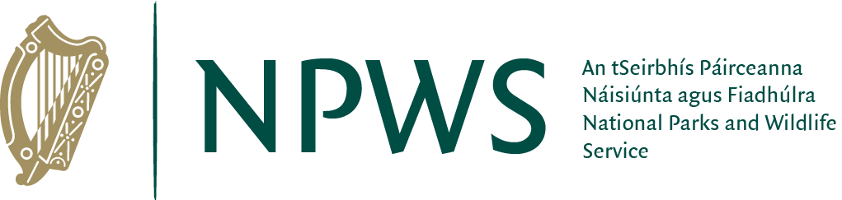
npws.ie
National Parks and Wildlife Service

